**Project Synopsis**

on

**A Complete website with backend using**

**PHP, MYSQL, and PDO**

In the partial fulfillment for the award of

BACHELOR OF ENGINEERING

In

COMPUTER SCIENCE & ENGINEERING



**Submitted by**

Smriti Rani GCS 1830033

Aakriti Raj GCS 1830040

Dikshita Garg GCS 1830041

**Under the Guidance of**

Dr.Utkarsh Sir

Assistant Professor/Associate

(CSE Department)

**Sant Longowal Institute of Engineering & Technology, Longowal – 148106**

**District – Sangrur, Punjab**

**10 March, 2021**

**Index**

|  |  |
| --- | --- |
| **S.No.** | **Topics Covered** |
| 1 | Introduction |
| 2 | Problem Definition |
| 3 | Proposed work |
| 4 | Objectives |
| 5 | Methadology /Technology |
| 6 | Hardware and Software requirements |
| 7 | Components of XAMPP |
| 8 | XAMPP format support |
| 9 | Installation of XAMPP |
| 10 | Creating MySQL database at the localhost |
| 11 | Create database |
| 12 | Inserting dummy data in a database |
| 13 | Output |
| 14 | Code Input |
|  |  |

**Introduction**

This project is about complete web development.Our goal of this project report is to build a complete website with a backend using PHP,MYSQL, and PDO.We are using PHP in our project as we all know PHP is a widely used, open-source scripting language and it is powerful enough to be at the core of the biggest blogging system on the web.It is deep enough to run the largest social network (Facebook).PHP can generate dynamic page content and can create,open,read, write,collect form data,send and receive cookies,can also add delete,modify data in our database.

Since we wanted to create a dynamic website that makes use of PHP code so we needed an Apache server to compile our PHP code.Also,we wanted to perform some operations related to a database such as storing data into a database or fetching data from a database.So for this,we needed to have MySql,MariaDB database functionality.This is why we overall needed to use XAMPP to fulfill the requirements to run our PHP project.

XAMPP offers the run environment or executes codes and tasks of our PHP language programming.It is open-source and free to use.XAMPP is one of the best Apache distribution that helps web developers to create a local web server for testing and deployment purposes.It was designed to be one of the easiest ways to install,run a development server and it is the most complete package.

(X-Cross-platform,A-Apache,M-MariaDB,PHP,P-Perl)

A wide range of relational database management systems such as MYSQL,SQ Lite, and PostgreSQL can be used by PHP.PDO (PHP data objects) is a new database connection abstraction library that has been offered by the PHP 5.1 version.PDO works by providing a standard set of functions for common database operations such as connecting, querying,the result set processing,and error handling,and internally translating these functions to native API calls understood by the database in use.

**Problem Definition**

Building a complete web development project using PHP,MYSQL and PDO.This project is to develop a working website having dynamic pages and all the other features which the websites have right from the post section to the comment section.

PHP is the language that we have used in our project as it has remained one of the most versatile and pragmatic web development languages in the world today.It’s range of functionalities, amazing array of add-ins to extend functionalities,open-source nature, and tremendous online community support have made PHP a perennial favorite amongst newbies as well as established development agencies worldwide.

**Proposed Work**

The proposed work of this project is to create a dynamic website that contains dynamic pages such as templates, content,scripts,etc.The dynamic website displays various content types every time it is browsed.

Nowadays sites have to change constantly and provide up-to-date news,information,stock,prices, and customized pages.PHP and SQL are two ways to make our site dynamic.

PHP is a robust,server-side,open-source scripting language that is extremely flexible and fun to learn and MYSQL is the standard query language for interacting with databases.MYSQL is an open-source,SQL database server that is more or less free and extremely fast.MYSQL is also cross-platform as PHP.Both of these helps in providing an interactive,user-friendly website and also facilitates visitors to openly interact while producing genuinely dynamic and flexible content.

The features of a dynamic website are Page Management,File Collection,Guestbook,Search Opportunity,Menus in management,Color and front management,photo Album.In dynamic websites there is complete control over the content and search engine optimization can be improved.There are options to record user information and to monitor user’s navigation over the website.They are easy to add,change and control all the content.

**Objectives**

Some of the benefits of a dynamic website are:

**Easy Updating**: The biggest advantage of a dynamic website is that it can be easily updated as per the needs of the owner of the website.No expert computer knowledge is required in changing the dynamic website and a single change in the template file would bring the design change in all the pages with that particular file.It can be quickly updated to become responsive to various screen sizes that were impossible with a static one.

**User friendly**: Dynamic websites are very user-friendly.It is extremely important to showcase to your clients that you are serious about business and hence to get them back on to our website numerous times,one should opt for dynamic websites.Users can easily make changes to the website as per their requirements.

**Interactive**: Users can leave a reply or comment on the sites based on their real-time experience and this helps the owner of the website to know how the customers feel about their business, products,or their website.User can also ask questions which would be reverted by the owner of the website.This makes a Dynamic website interactive.

**Professional look**: The dynamic website looks more professional than static websites.Static websites often look unprofessional.Simply showcasing your products on the website and asking the user to call and book an order is caveman style now.So dynamic websites are preferred more because of their look.

**Easily manageable**: Dynamic sites use languages like PHP,MVC to interact with information stored in databases.These websites can be built with an admin panel which can help the website owner to make changes in the website in a blink without any knowledge of coding.

**Methodology/Technology or any specific tool to be used**

This website has the involvement of PHP PDO, and MYSQL.For all of this to be used we need to install XAMPP.It is the title used for a compilation of free software.The name is an acronym, with each letter representing one of the five key components.The software packet contains the web server Apache, the relational database management system MYSQL, and the scripting languages Perl and PHP.The initial X represents an operating system that works with Linux,Windows, and Mac OS X.

**Apache**: The open-source web server Apache is the most widely used server worldwide for the delivery of web content.The server application is made available as free software by the apache software foundation.

**MYSQL/Maria DB**: It contains one of the most popular relational database management systems in the world.in combination with the webserver Apache and the scripting language PHP, MYSQL offers data storage for web services.

**PHP**: The server-side programming language PHP enables users to create dynamic websites or applications.PHP can be installed on all platforms and supports a number of diverse database systems.

**Perl**: The scripting language Perl is used in system administration,web development,and network programming.Like PHP,Perl also enables users to program dynamic web applications.

**Hardware requirements**

Operating system

X86 64 –bit CPU

4GB RAM

5 GB free disk space

**Software requirements**

A PHP engine – version 5.Included in XAMPP Windows.

A Web server – Apache HTTP Server 2.2 is recommended. Included in XAMPP Windows.

A Database server – MYSQL Server 5.0 is recommended. Included in XAMPP Windows.

A PHP debugger – Xdebug 2.0 or later(Optional)

## **Components of XAMPP**

## As defined earlier,XAMPP is used to symbolize the classification of solutions for different technologies.It provides a base for testing of projects based on different technologies through a personal server.XAMPP is an abbreviated form of each alphabet representing each of its major components.This collection of software contains a web server named **Apache**,a database management system named **MariaDB** and scripting/ programming languages such as **PHP** and **Perl**.

Many other components are also part of this collection of software and are explained below.

1. **Cross-Platform:** Different local systems have different configurations of operating systems installed in them.The component of cross-platform has been included to increase the utility and audience for this package of Apache distributions.It supports various platforms such as packages of Windows,Linus, and MAC OS.
2. **Apache:** It is an HTTP cross-platform web server.It is used worldwide for delivering web content.The server application has been made free for installation and used for the community of developers under the aegis of Apache Software Foundation.The remote server of Apache delivers the requested files,images, and other documents to the user.
3. **MariaDB:** Originally,MySQL DBMS was a part of XAMPP,but now it has been replaced by MariaDB.It is one of the most widely used relational DBMS,developed by MySQL.It offers online services of data storage,manipulation,retrieval,arrangement,and deletion.
4. **PHP:** It is the backend scripting language primarily used for web development.PHP allows users to create dynamic websites and applications.It can be installed on every platform and supports a variety of database management systems.It was implemented using C language. PHP stands for **Hypertext Processor**.It is said to be derived from Personal Home Page Tools,which explains its simplicity and functionality.
5. **Perl:** It is a combination of two high-level dynamic languages,namely Perl 5 and Perl 6. Perl can be applied for finding solutions for problems based on system administration, web development,and networking.Perl allows its users to program dynamic web applications.It is very flexible and robust.
6. **phpMyAdmin:** It is a tool used for dealing with MariaDB.Its version 4.0.4 is currently being used in XAMPP.Administration of DBMS is its main role.
7. **OpenSSL:** It is the open-source implementation of the Secure Socket Layer Protocol and Transport Layer Protocol.Presently version 0.9.8 is a part of XAMPP.
8. **XAMPP Control Panel:** It is a panel that helps to operate and regulate other components of the XAMPP.Version 3.2.1 is the most recent update.
9. **Webalizer:** It is a Web Analytics software solution used for User logs and prodetails about the usage.
10. **Mercury:** It is a mail transport system, and its latest version is 4.62.It is a mail server, which helps to manage the mails across the web.
11. **Tomcat:** Version 7.0.42 is currently being used in XAMPP.It is a servlet based on JAVA to provide JAVA functionalities.
12. **Filezilla:** It is a File Transfer Protocol Server,which supports and eases the transfer operations performed on files.Its recently updated version is 0.9.41.

## **XAMPP Format Support**

XAMPP is supported in three file formats:

* **.EXE**- It is an extension used to denote executable files making it accessible to install because an executable file can run on a computer as any normal program.
* **.7z - 7zip file**- This extension is used to denote compressed files that support multiple data compression and encryption algorithms.It is more favored by a formalist, although it requires working with more complex files.
* **.ZIP**- This extension supports lossless compression of files.A Zipped file may contain multiple compressed files.The **Deflate algorithm** is mainly used for compression of files supported by this format.The .ZIP files are quite tricky to install as compared to .EXE

Thus .EXE is the most straightforward format to install,while the other two formats are quite complicated and complex to install.

## **How to install Xampp?**

It is completely free and easy to install Apache distribution containing MySQL,PHP and Perl. First,download XAMP from <https://www.apachefriends.org/download.html>.In the first page,select the components you want to install.

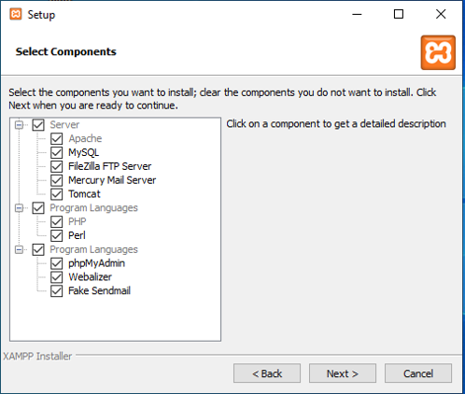

FIG NO.1: Setup

Select the installation directory so that all the components that you choose will be installed in this directory.

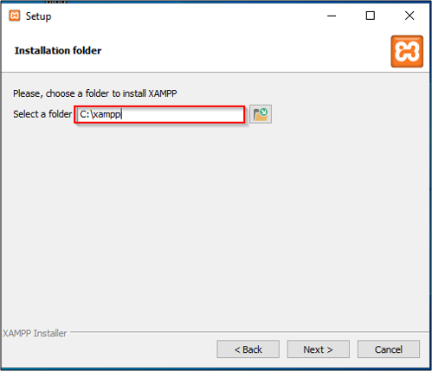

FIG NO.2:Setup

XAMP also allows you to easily [install PHP](https://www.edureka.co/blog/php-tutorial-for-beginners/#ide)-based applications.Bitnami module provides the easiest way to install WordPress,Drupal or Joomla among others on top of your XAMP after the installation you will see the control panel.

Once we are done with Xampp installation, let’s move ahead and see how to run a PHP file in xampp server.

## **How to run a PHP program in Xampp step-by-step?**

* Write this program in a notepad and save it as file.php or any other name.
* <?php echo " hello ashok" ?>
* After completion of the installation, you can use the XAMPP Control Panel to start/ stop all servers.
* Start Mysql and Apache servers.

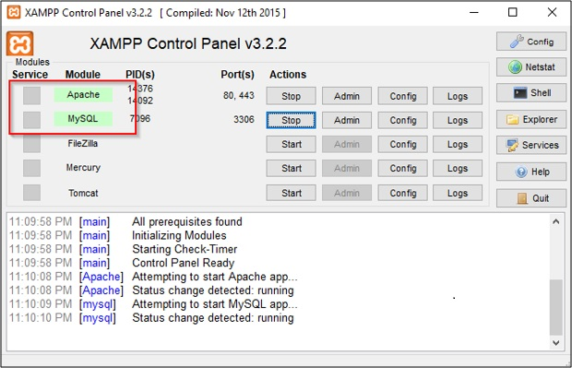

FIG NO.3:XAMPP Control Panel

Copy file.php to htdocs (C:/Program Files/XAMPP/htdocs)

You can also create any folders inside htdocs folder and save our codes over there.

To get the dashboard for localhost: search [http://localhost](http://localhost/) in any browser.

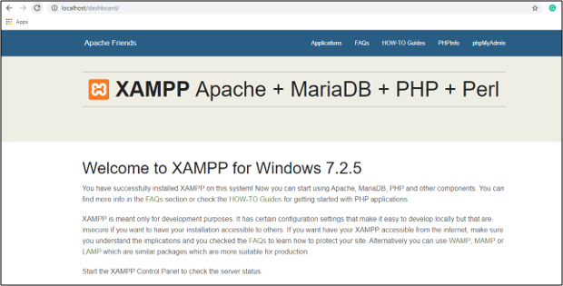

FIG NO.4:Localhost

Now to run your code, open localhost/file.php then it gets executed.

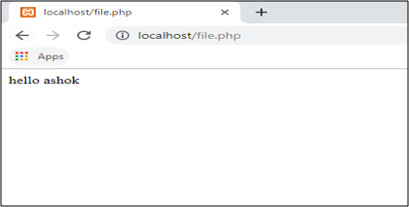

FIG NO.5:Localhost

## **Create MySQL Database at the Localhost**

To connect to a MySQL Database:

1. Create Database
2. Create a Folder in htdocs
3. Create Database Connection File In PHP
4. Create a new php file to check your database connection
5. Run the server

[PHPMyAdmin](https://www.cloudways.com/blog/installation-phpmyadmin/) is a control panel from where you can manage the database that you’ve created. Open your browser and go to localhost/PHPMyAdmin or click “Admin” in XAMPP UI.

When we first installed XAMPP,it only created the username for it to be accessed,we now have to add a password to it by ourselves.For this,we have to go to the User account where the user is the same as the one shown in this picture:



FIG NO.6:Creating MYSQL Database

Now click Edit privileges and go to Change Admin password, type our password there and save it. Remember this password as it will be used to connect to your Database.

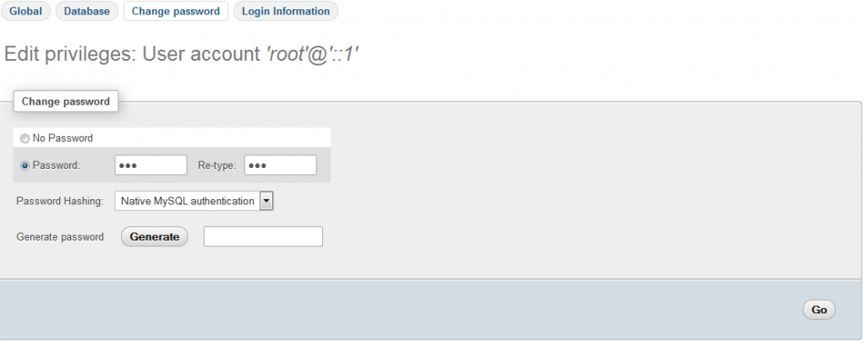

FIG NO.7:Creating MYSQL Database

Note:It is not necessary to change the password to access databases on the localhost.It is a good practice and that is why we have used a password.

**Create Database**

Now return to the homepage of PHPMyAdmin.Click the New button to create a new database.

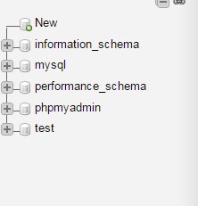

FIG NO.8:Creating Database

In the new window, name our database as per our need, we are naming it “**practice**”.Now select Collation as utf8_general_ci, as we are using it for learning purposes and it will handle all of our queries and data.Now click on Create and our database will be created.

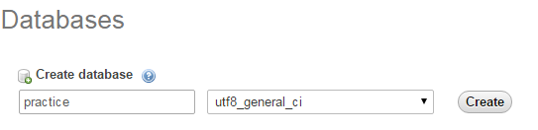

FIG NO.9:Creating Database

The newly created database will be empty now, as there are no tables in it

FIG NO.10:Creating Database

**Create a Folder in htdocs**

Now,locate the folder where we installed XAMPP and open the htdocs folder (usually c:/xampp).Create a new folder inside c:/xampp/htdocs/ and name it “practice” we will place web files in this folder.Why we have created a folder in htdocs? XAMPP uses folders in htdocs to execute and run your PHP sites.

Note:If you are using WAMP,then add your practice folder in c:/wamp/www folder.

**Create Database Connection File In PHP**

Create a new PHP file and name it db_connnection.php and save it.A separate database connection file is created because if you have created multiple files in which you want to insert data or select data from the databases,we don’t need to write the code for database connection every time.we just have to include it by using PHP custom function **include** (include ‘connection.php’) on the top of your code and call its function and use it.It also helps when we are moving your project location from one PC to another and you have to change the values on the single file and all the changes will be applied to all the other files automatically.Write the following code in your db_connection file.

1. <?php
2. **function** OpenCon()
3. {
4. $dbhost = "localhost";
5. $dbuser = "root";
6. $dbpass = "1234";
7. $db = "example";
8. $conn = **new** mysqli($dbhost, $dbuser, $dbpass,$db) **or** **die**("Connect failed: %s\n". $conn -> error);
9. **return** $conn;
10. }
11. **function** CloseCon($conn)
12. {
13. $conn -> close();
14. }
15. ?>

Here is the explanation of the variable that we have used in our db_connection file:

1. $dbhost will be the host where your server is running it is usually localhost.
2. $dbuser will be the username i.e. **root** and $dbpass will be the password which is the same that you used to access your PHPMyAdmin.
3. $dbname will be the name of your database which we have created.

**Create a new PHP file to check our database connection**

Create a new PHP file to connect to your database. Name it index.php and add this code in this file.

1. <?php
2. **include** 'db_connection.php';
3. $conn = OpenCon();
4. **echo** "Connected Successfully";
5. CloseCon($conn);
6. ?>

Run it!

Now open our browser and goto localhost/practice/index.php and you should see this screen:

**Inserting dummy data in a database.**

For inserting dummy data in a database we need to open xampp , and then go to the admin section in MySql.Here we can create the table,and fill desired information into it.We can perform various data in the given fields.

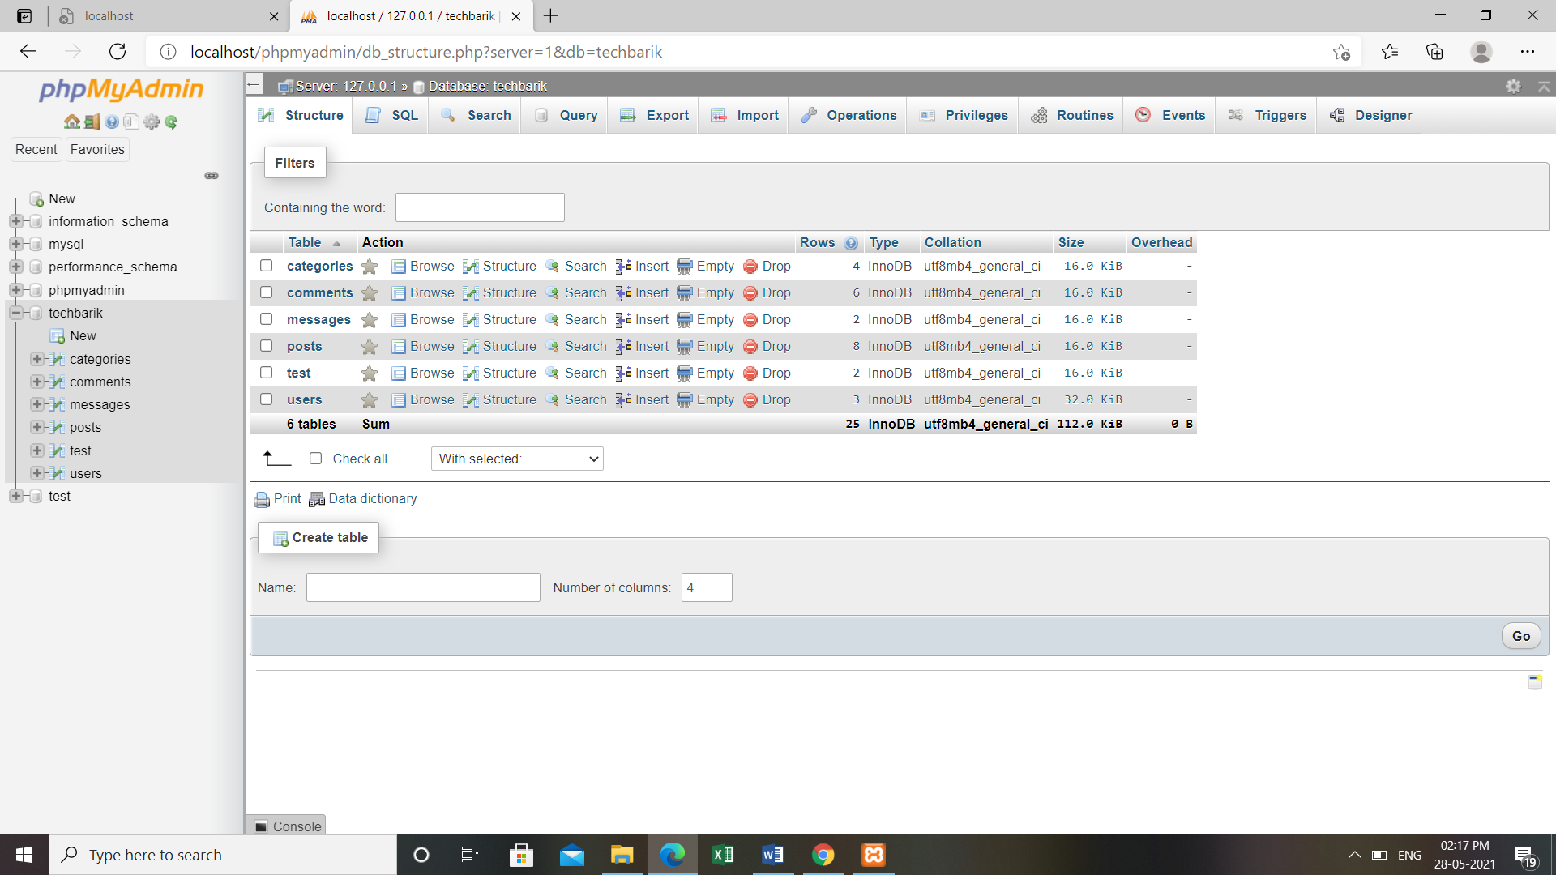

FIG NO.11:Creating dummy data

In the database we have created a table named techbarik and in this table,we have various sub tables which are categories,comments,messages,posts,tests, and users.In the creation of any table in the database,we have to fill in the number of columns we want and other different details regarding the data we are entering like name,type,length,null index and AI comments.Type includes int, varchar, text and date.

We have stored all the dummy data on these subtables so that they can be shown on our website.

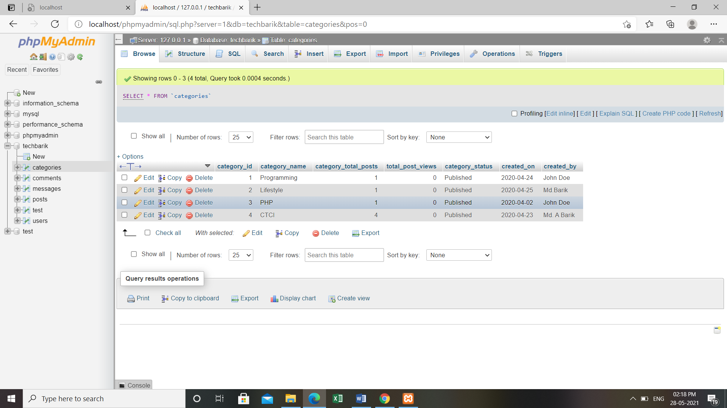

FIG NO.12:Creating dummy data

In the categories section,we have created four different categories which are Programming, Lifestyle,PHP, and CTCI.Further in this project,we have added various posts in all of the respective categories.After creating the dummy data in the table we can further edit those data by simply clicking on the edit option.Similarly we can copy and delete the categories.

To insert more data we can click on the insert option present at the top section of the interface and then we will be shown all the fields where we can fill our desired data.

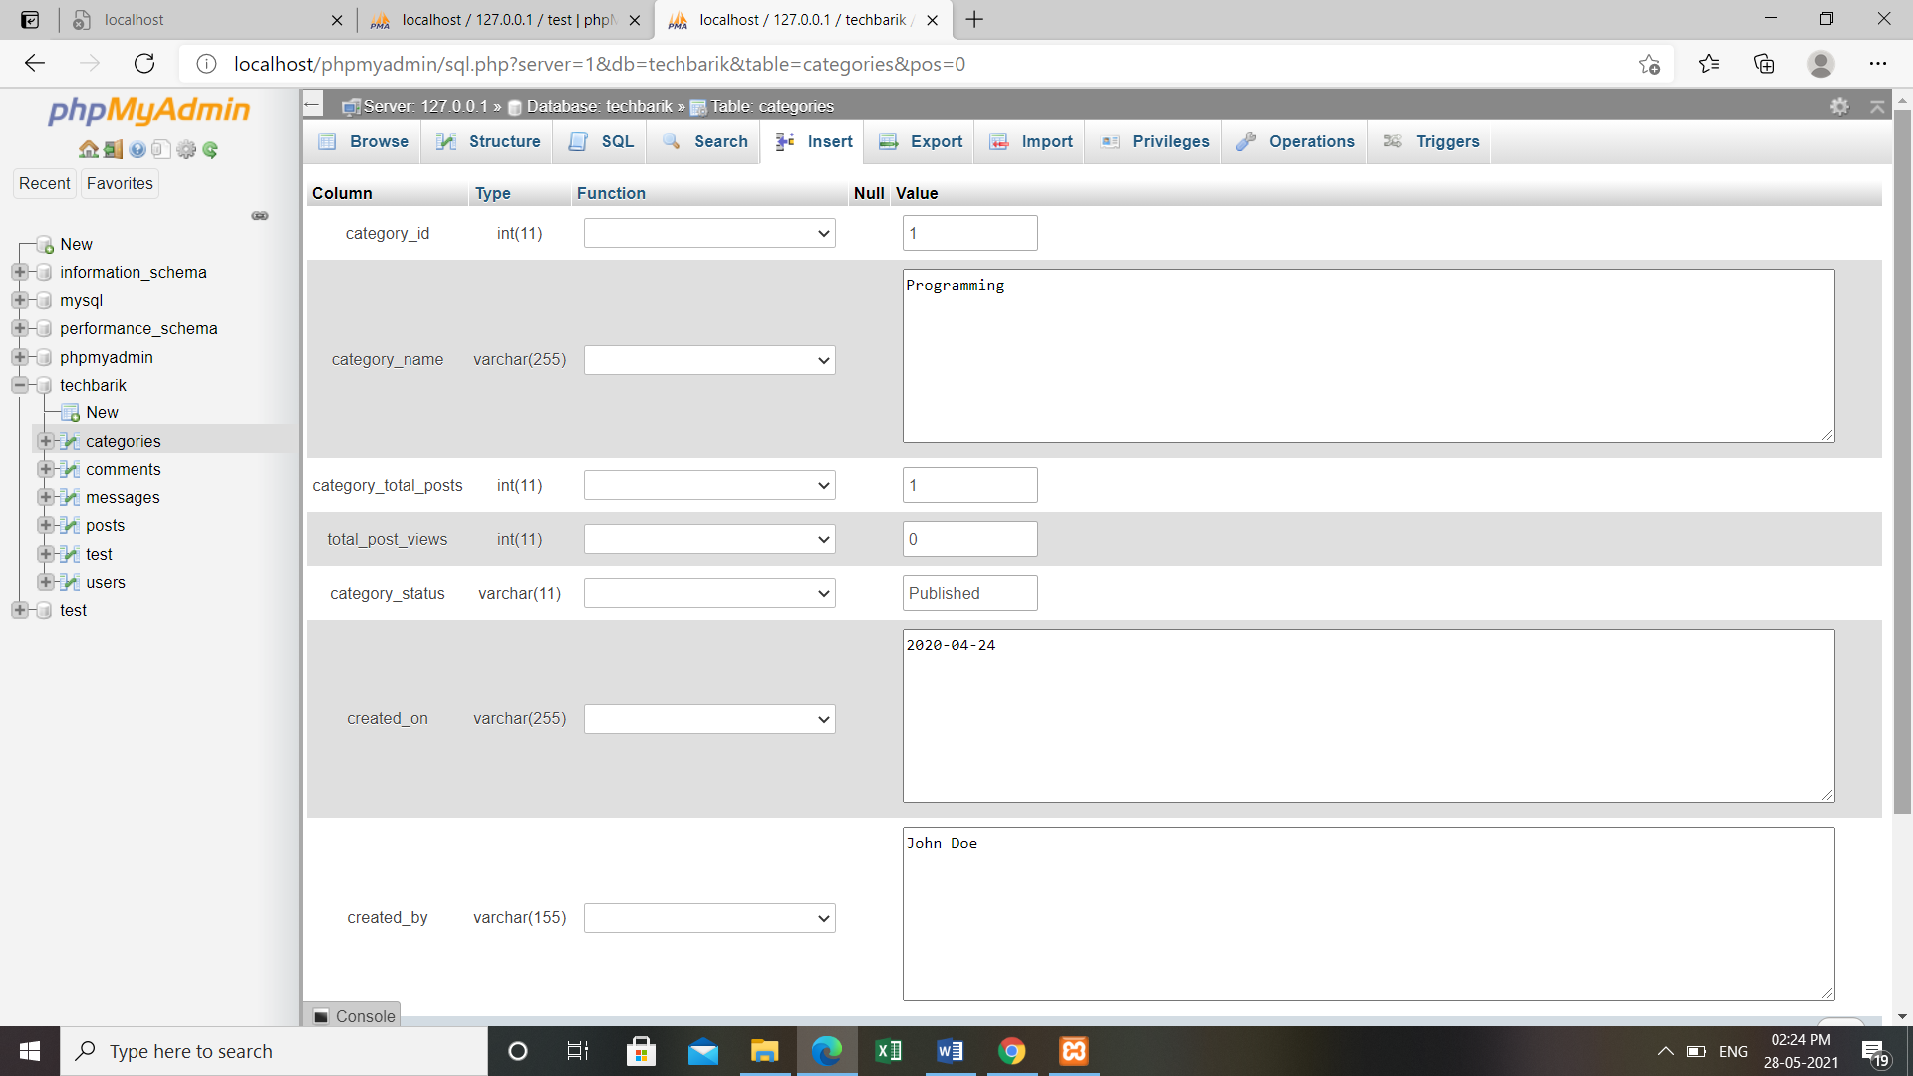

FIG NO.13:Creating dummy data

Inside the categoriessection we have different fields like category_id,category_name, category_total_posts,total_post_views,category_status,created_on and created_by.

In the category_id we can choose from the dropdown list where int,varchar,date, and text are present. We also have to select the length of the datatype which we have chosen.Then in the category_name,we have to write the name of the category.

After that,we will have to specify the total posts present in this category. In the total post views section,we are shown the views of a particular post and in the category status,we can choose from published or draft.After that,we have created on a field where we need to specify the date,and in the created by the field,we have to mention the name of the person who is creating it.

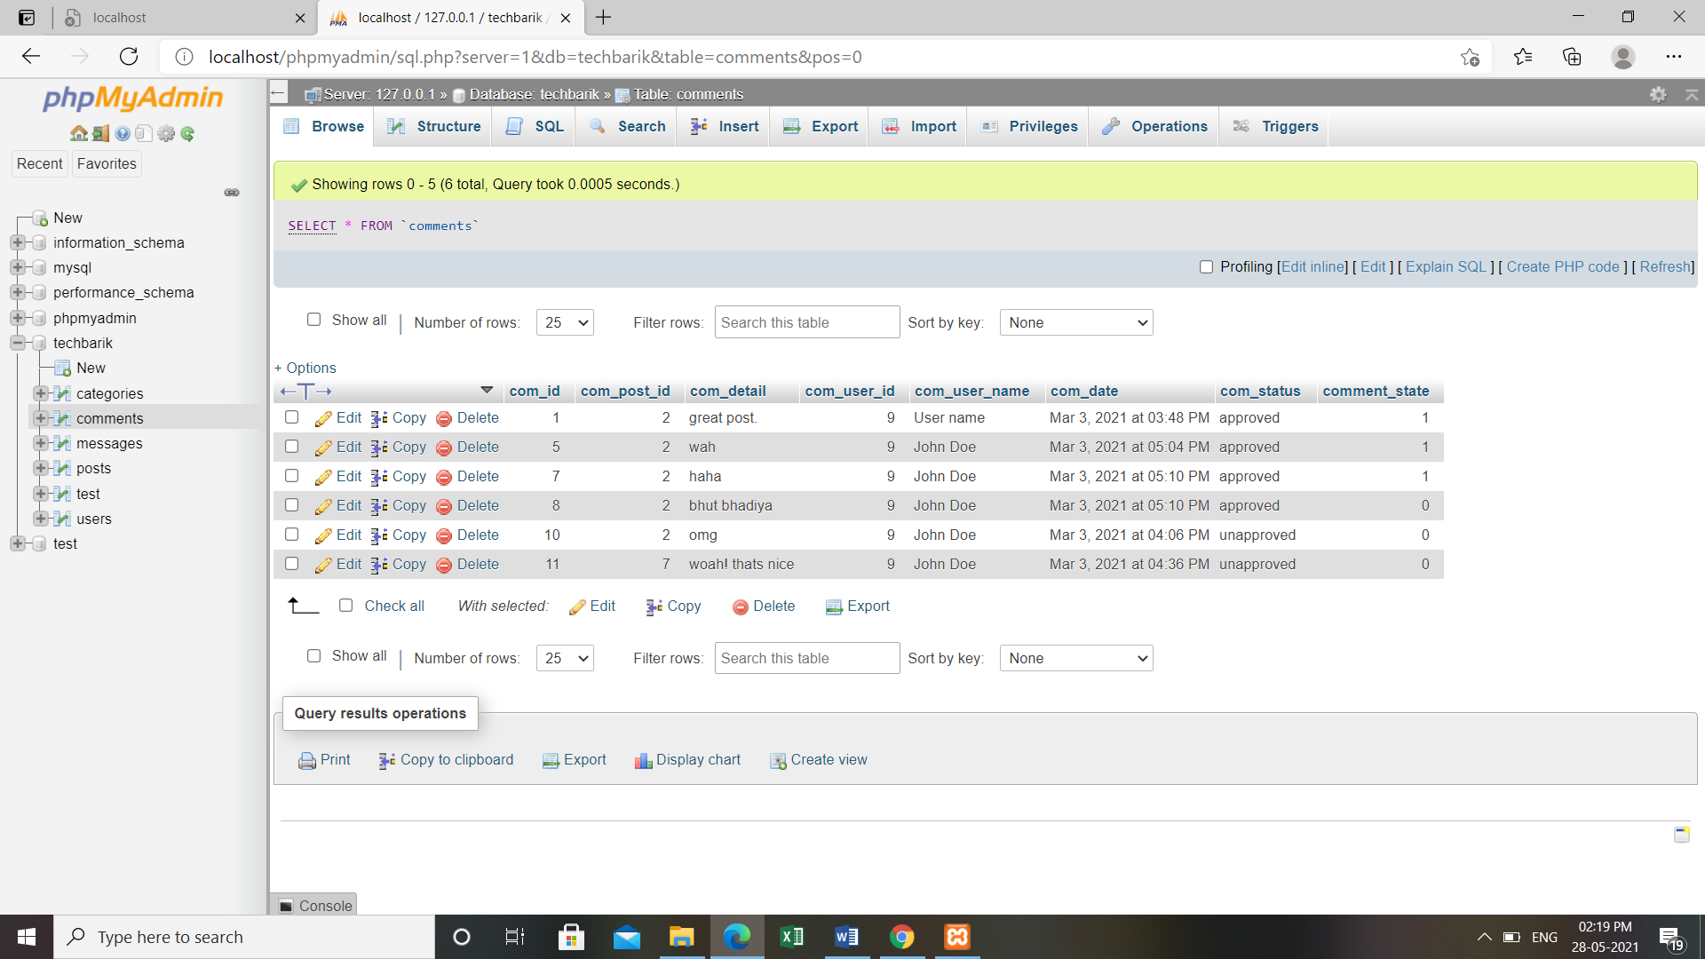

FIG NO.14:Creating dummy data

The other sub-table we have created in our database is the comments sub table.Here the comments done will be shown along with the details of the person who has commented.As we have done in categories section,we can edit,copy or delete any of the comment if we wish to.

Here we have the columns like com_id,com_post_id,com_detail,com_user_name,com_date, com_status and comment_status to store the details of the comments posted by various persons.

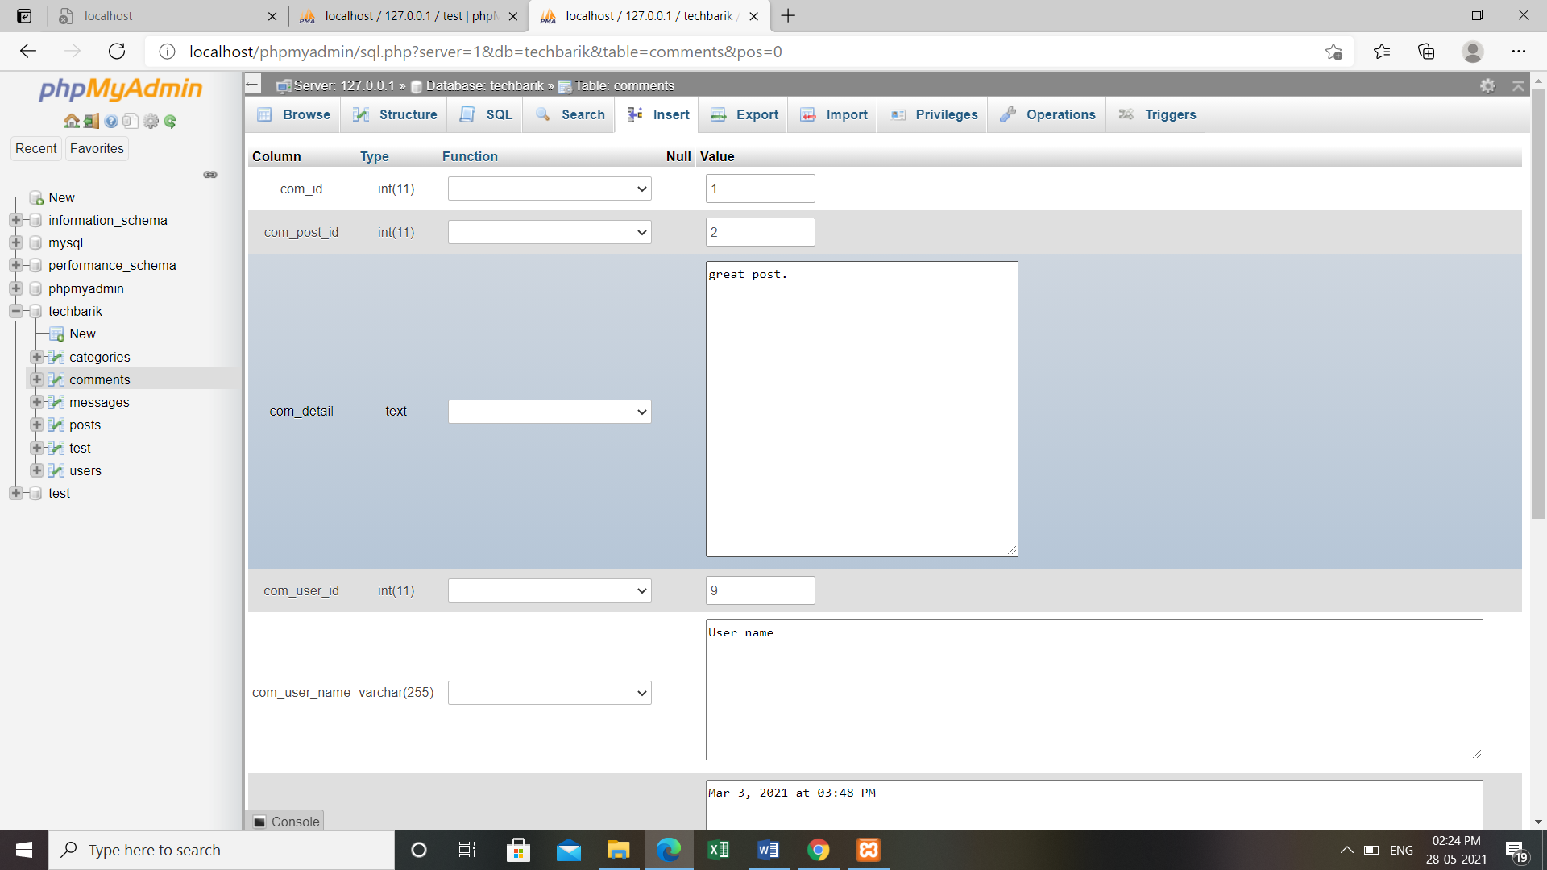

FIG NO.15:Creating dummy data

Inside the comments section we have to fill all the given information.In comment id section simply the id no. will be shown,Comment post id will show that the comment is regarding which post.In the comment details the comment we be shown.

In comment date the date of the comment along with the time will be mentioned and in the comment status field either approved or unapproved will be shown.

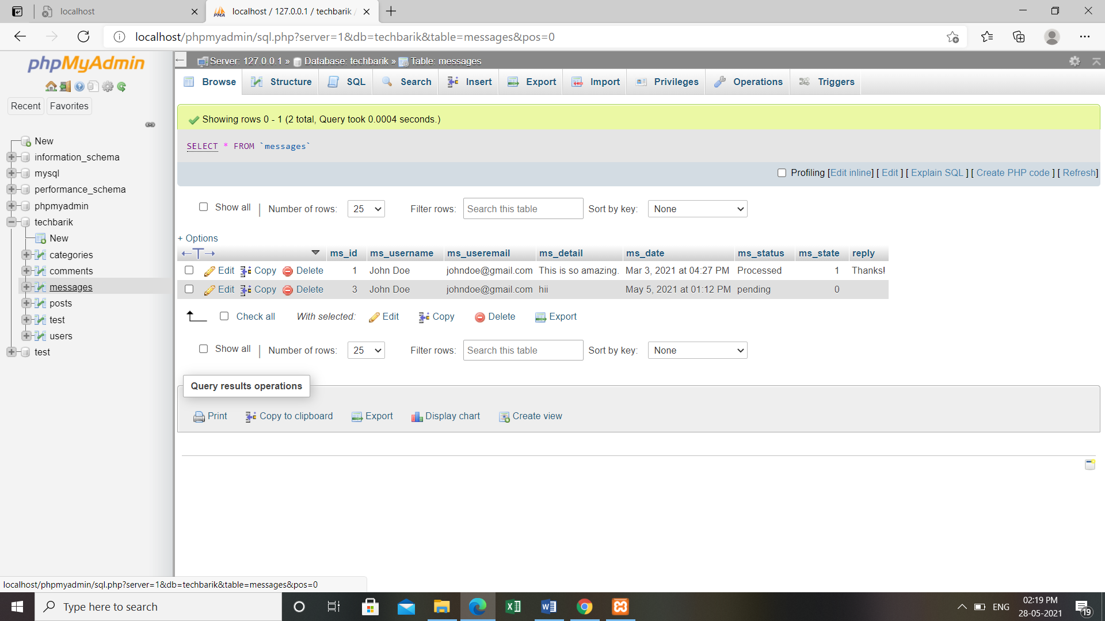

FIG NO.16:Creating dummy data

Then we have the message sub-table where are the messages coming from the visitor profile will be shown.Like all the other subtables we have the option to delete,copy and edit the rows where we can modify and data inside of the sub-table.In the message section,we have various columns like ms_id,ms_username,ms_detail,ms_date,ms_status and reply.

The information of the visitor who is messaging will be shown in all of these corresponding columns.

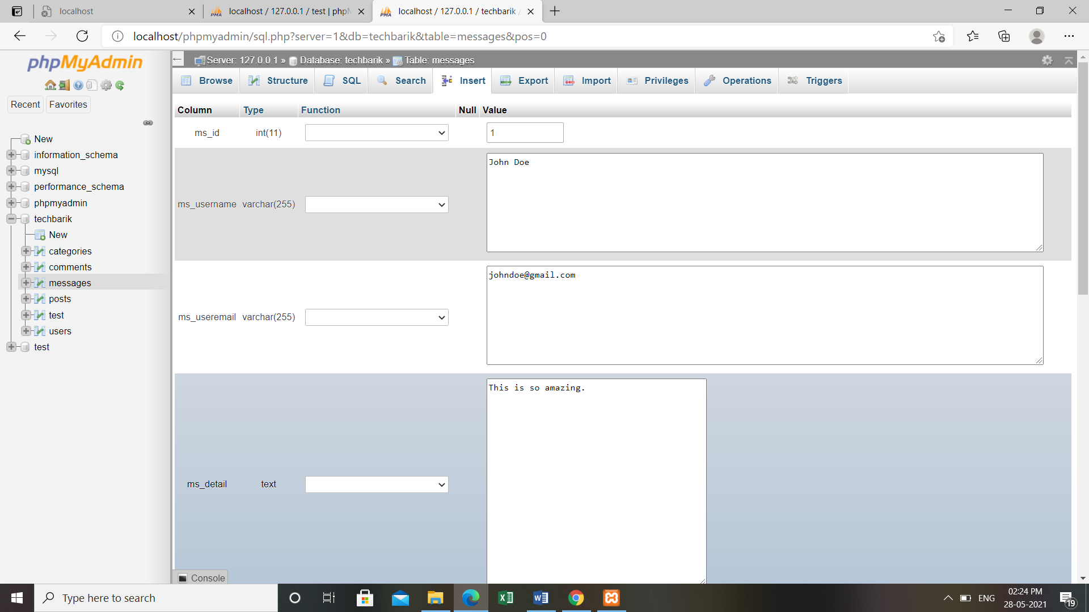

FIG NO.17:Creating dummy data

Inside the message section,the field like message username will contain the name of the visitor. The message user email field will have the email id of the visitor.In the same way,the message detail will show the proper message commented by the visitor.Message date will contain the date when the message is commented along with the time.

In the message status,we will be shown as either processed or pending.This depends on the admin i.e if the admin has viewed the message and has replied to it,then the message status will automatically be shown as process otherwise it will show as pending.In the reply section,the reply of the admin to the visitor will be shown.

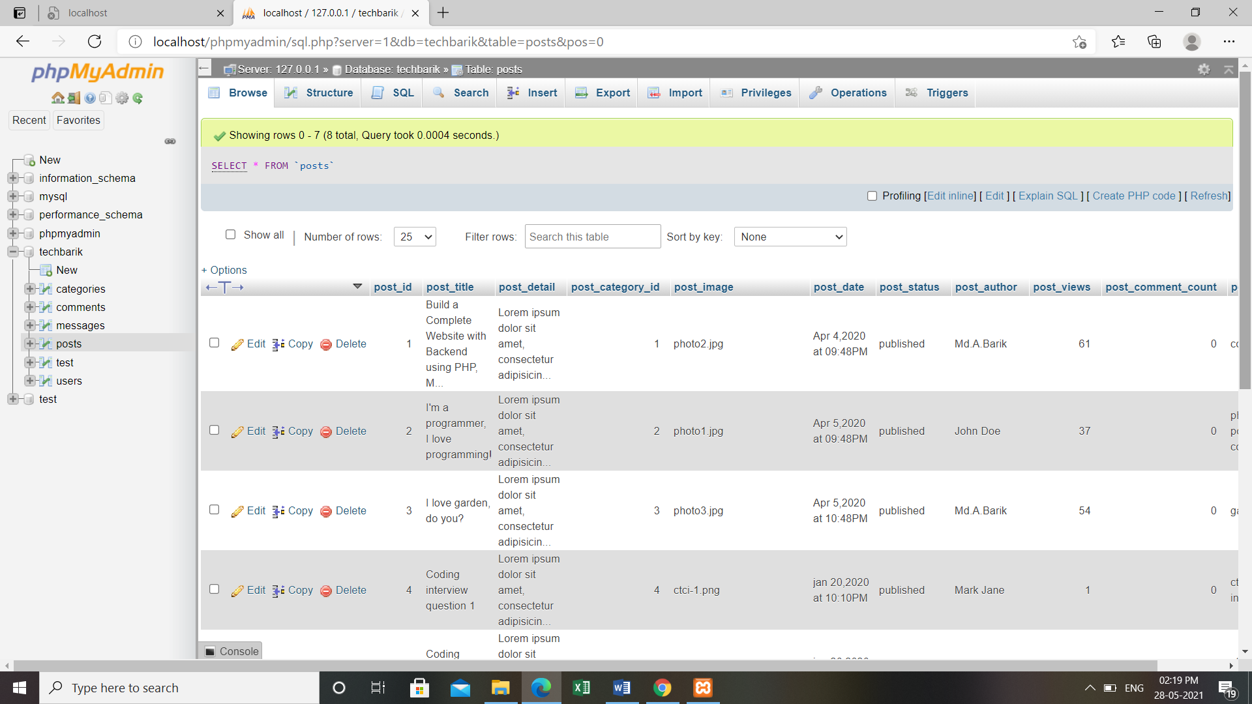

FIG NO.18:Creating dummy data

Then we have the posts sub-table which contains all the posts along with the details and the category to which the particular post belongs.

We can set the details of various posts in the fields like post_id,post_title,post_category_id, post_image,post_status,post_author,post_views,post_comment_count,post_image, and post_tags.

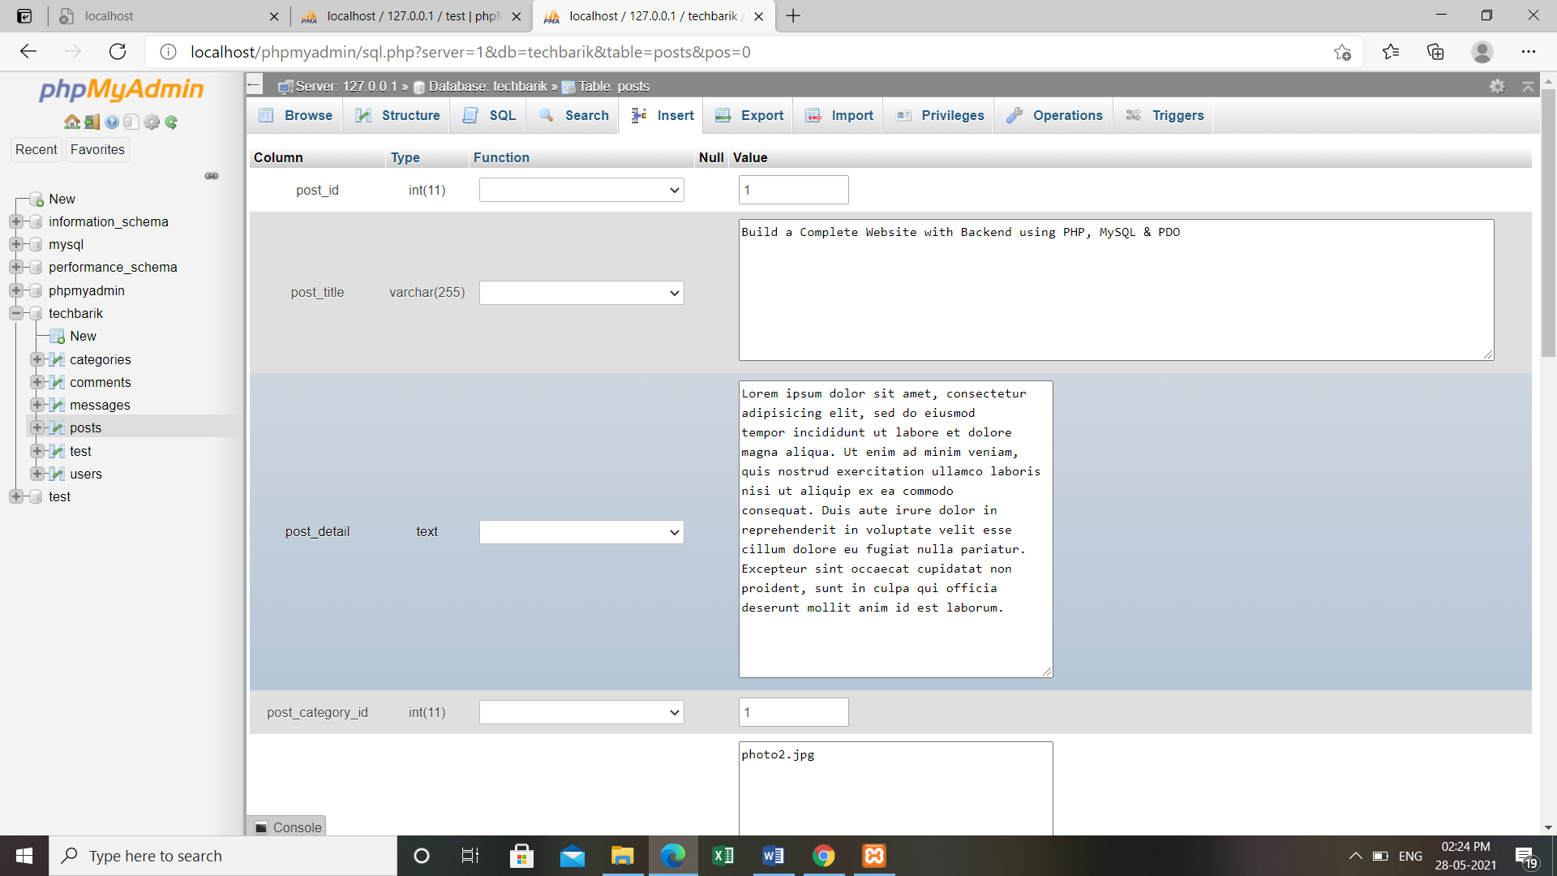

FIG NO.19:Creating dummy data

In the post sub-table,we have various fields like post_id which contains the id no. of the post.In the post title,we can mention the title regarding the post which will represent that post.In the post details field,the details of that post will be shown i.e we can write the details in brief which will be shown to the visitor.If we write a brief introduction about the post title then it will become easier for the visitor to understand the post more easily.In the post category id section,we have all the posts regarding each particular category.

In the post image, an image URL is mentioned which will be shown on the website.In the post date field, the date of the post will be shown i.e on which date the post has been created.If the post gets published then the post status field will show published.In the post views sections, all the views of the particular posts will be shown.

After filling the details, we can simply click on save to save all the information.

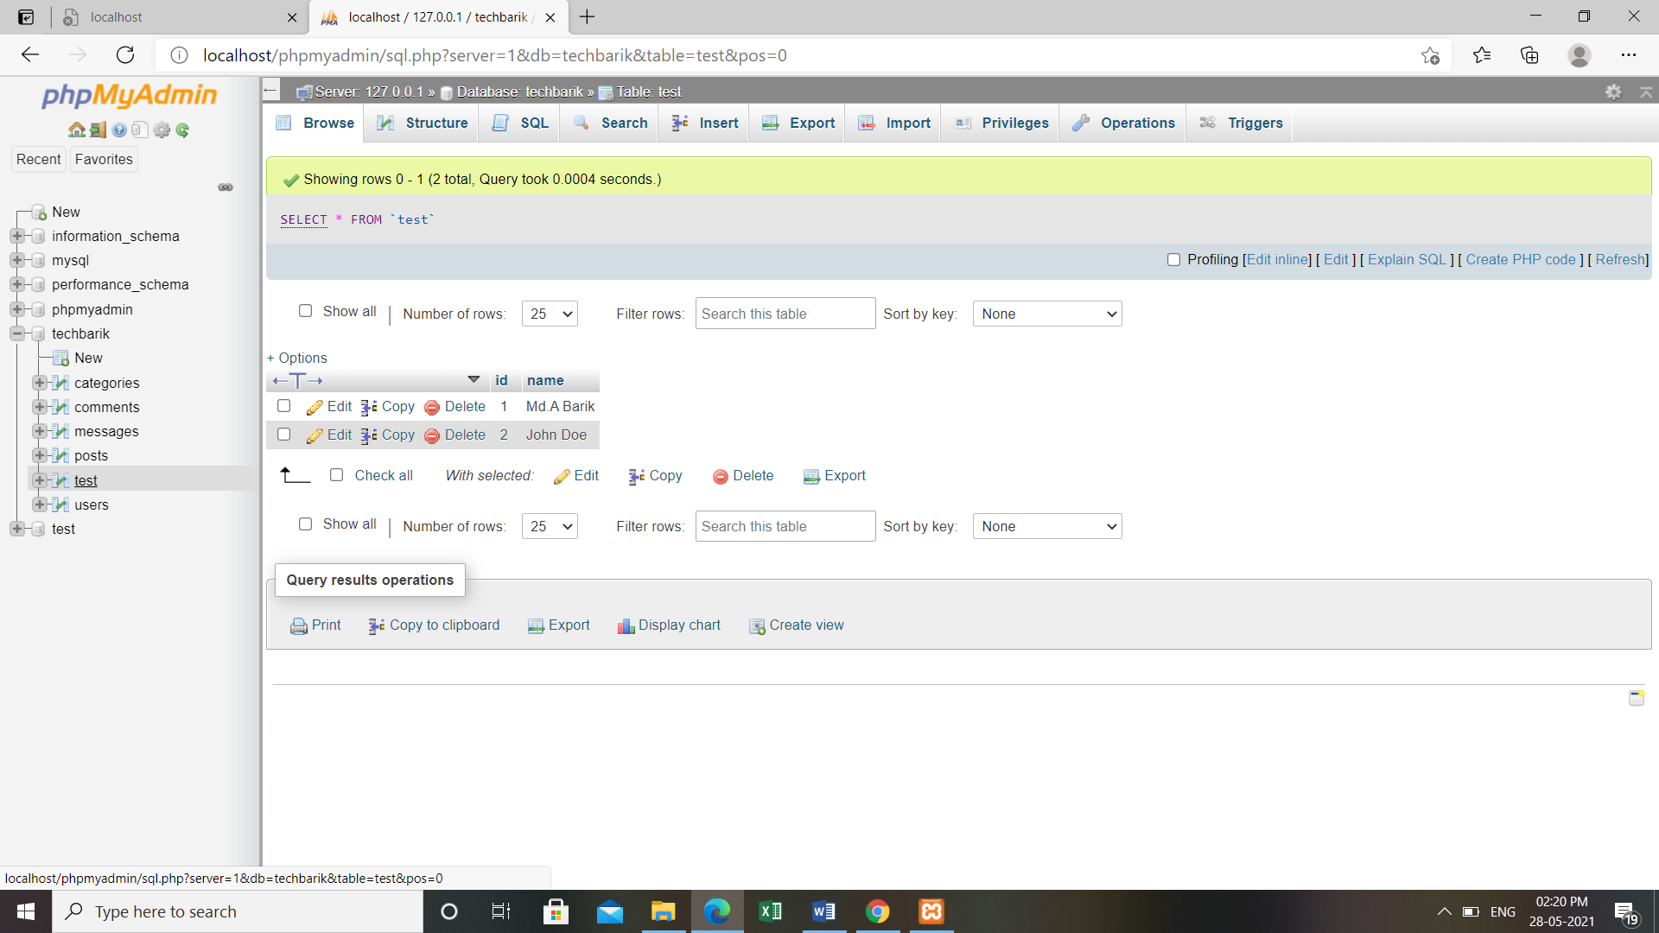

FIG NO.20:Creating dummy post

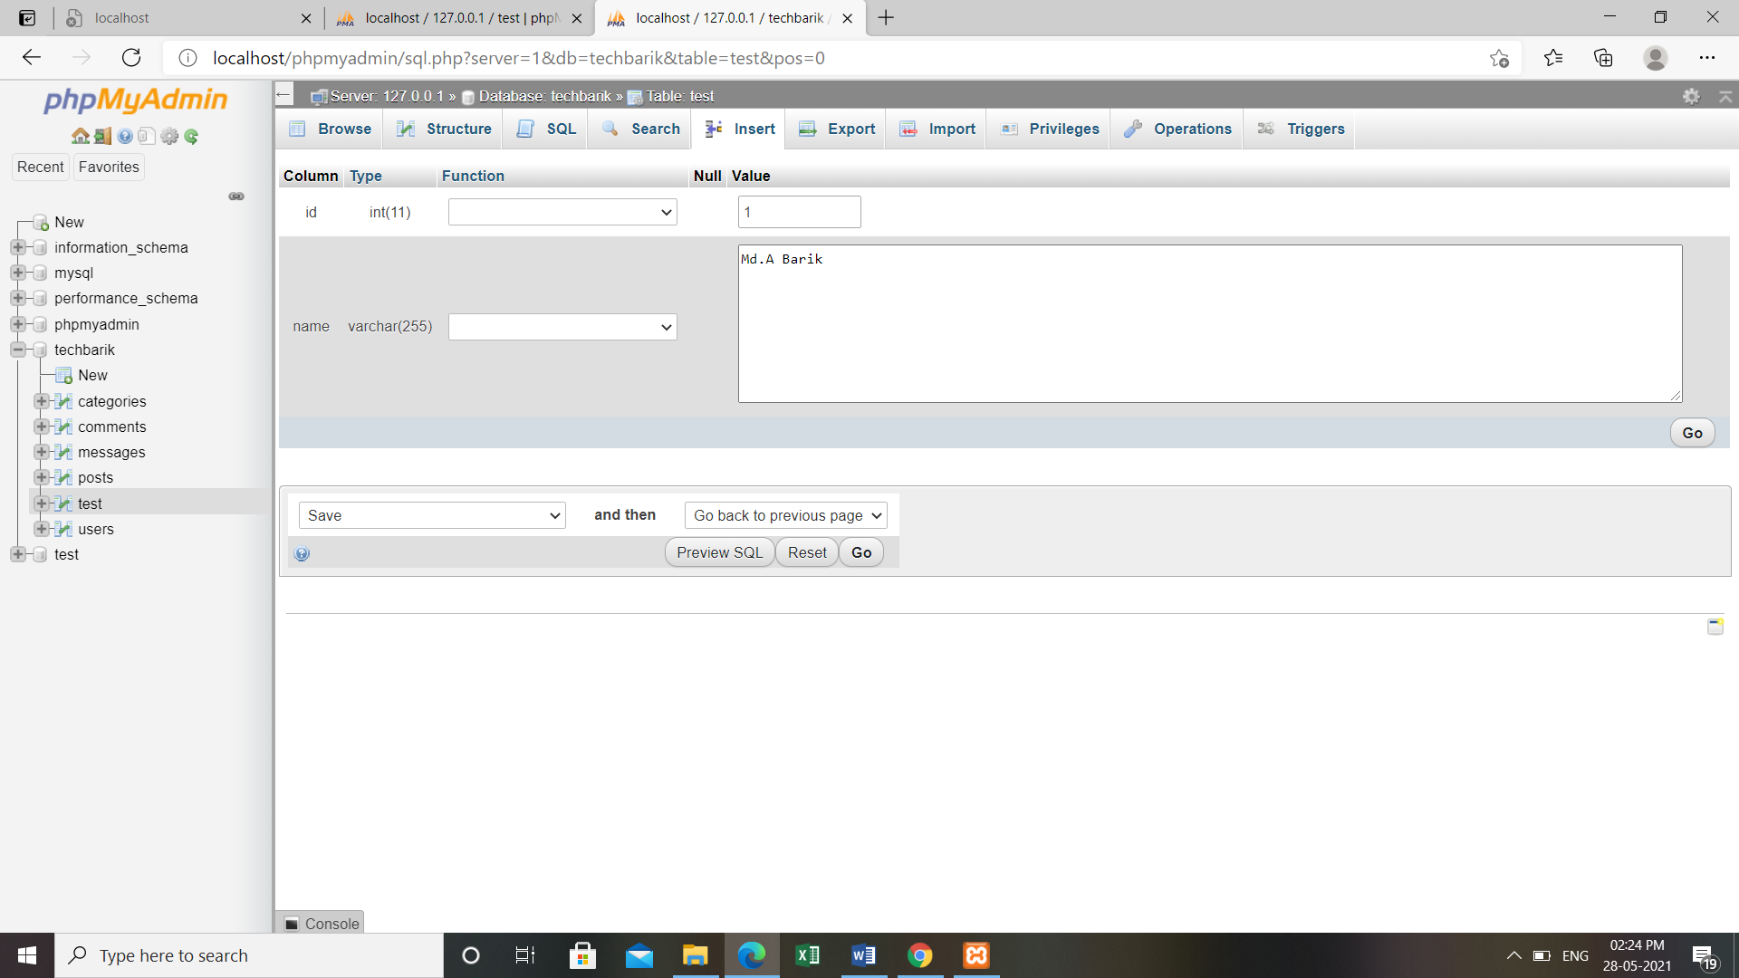

FIG NO.21:Creating dummy post

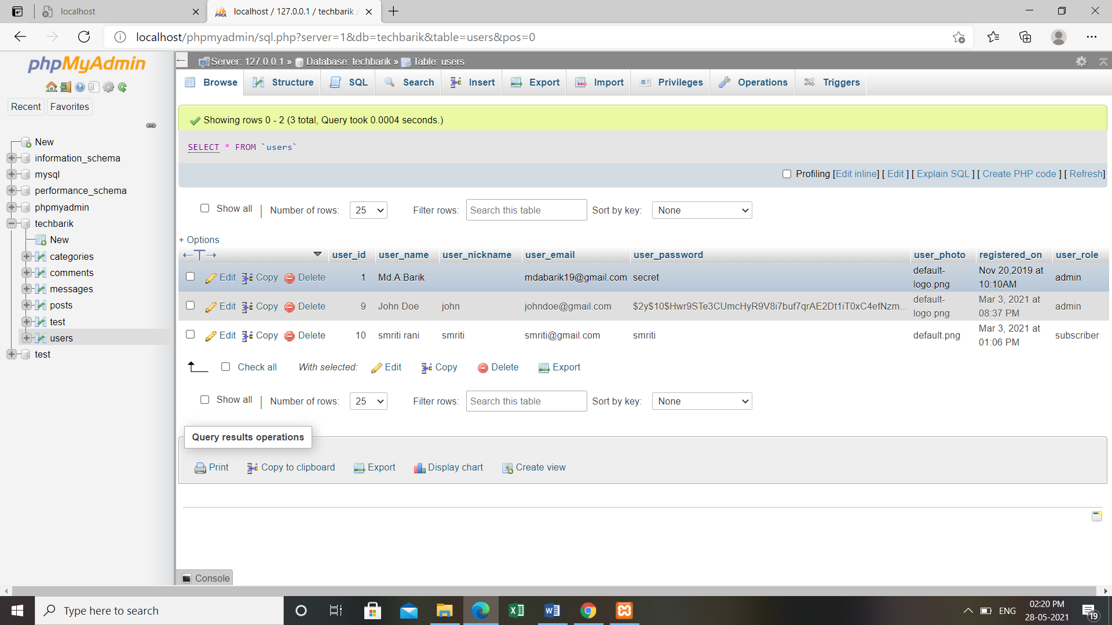

FIG NO.22:Creating dummy post

In the users' sub-table all the users who have signed in to the website will be shown along with their details. The users' subtable has various columns like user_id,user_name,user_nickname, user_password,user_photo,registered_on, and user_role.

We have mentioned the details like type,length, and null index of the particular columns.

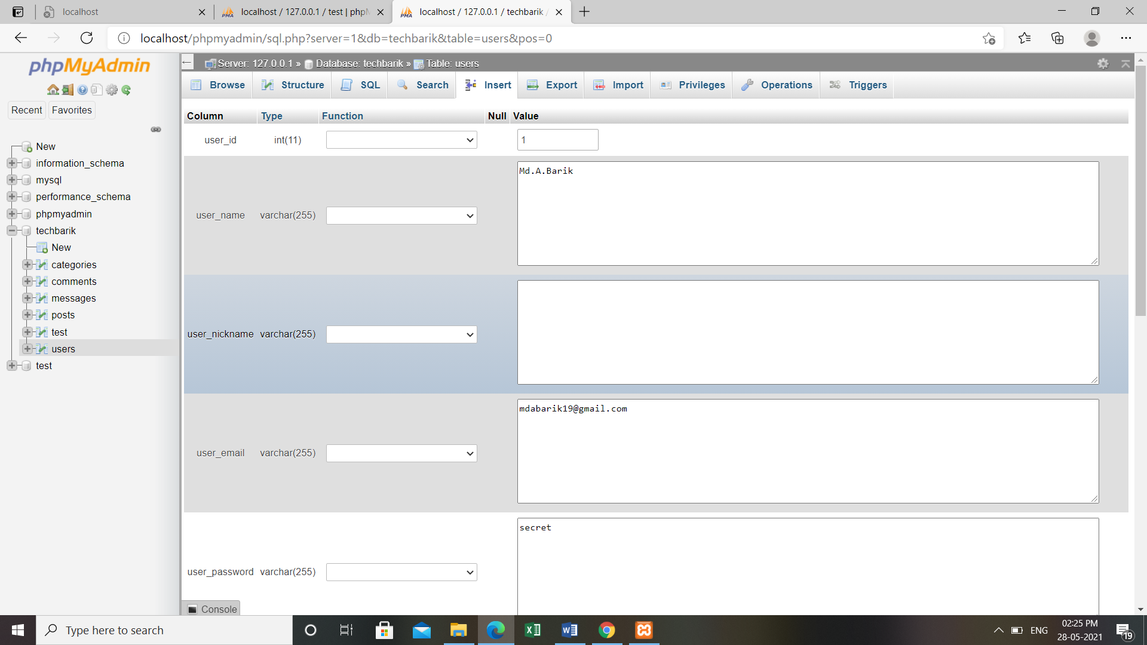

FIG NO.23:Creating dummy post

Inside the users' sub-table the desired fields are filled where the user name will show the name of the logged-in user.In the nickname, we can fill nickname of the user if we want to otherwise we can just leave the field empty.In the user email column,the email id will be shown through which the user has signed in to the website.

In the user password section,the password corresponding to the email id is there.If we save the password while log in to the website,then it will be saved in the database.In user photo column,the photo of user will be shown.

Then we have registered on where the date along with time will be shown and at last,the user role can be either admin or subscriber.If the user is made admin them only he can access the backend of the website.It depends on the admin that to whom he wants to provide access to the backend.

**OUTPUT**

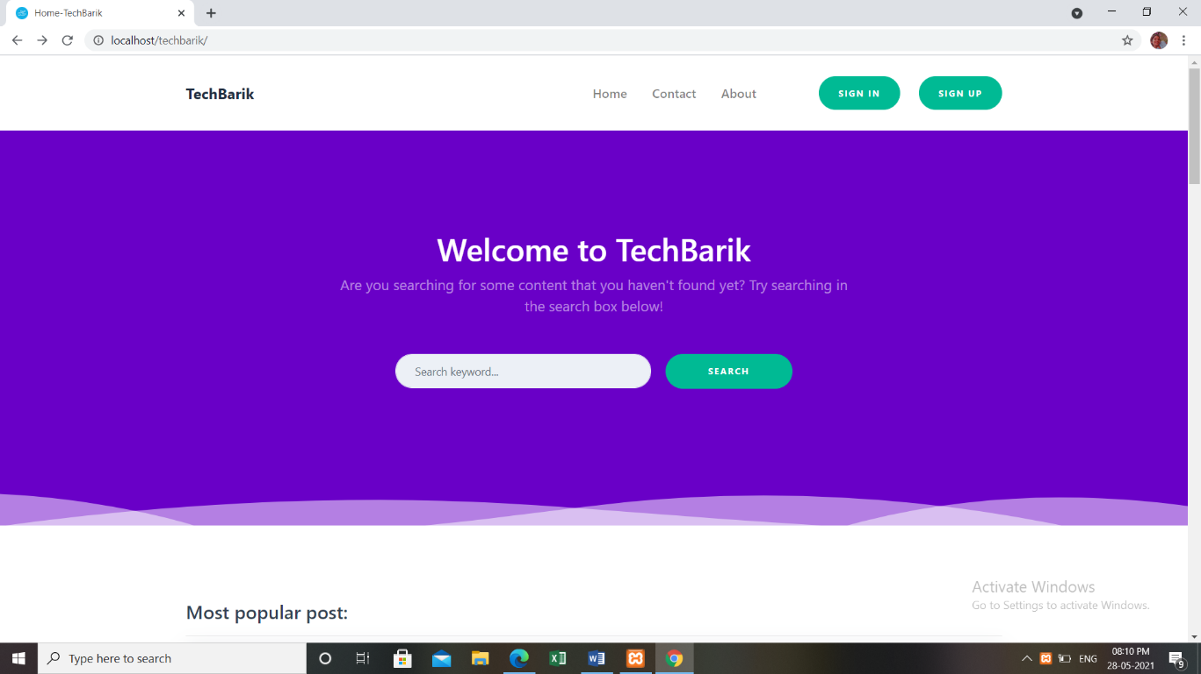

FIG NO.24:Website’s Interface

This is the interface of our website. We accessed our website by simply typing localhost/filename. The first page of our website show options like sign in and sign out. Other than this,there are options like Home,Contact, and About.

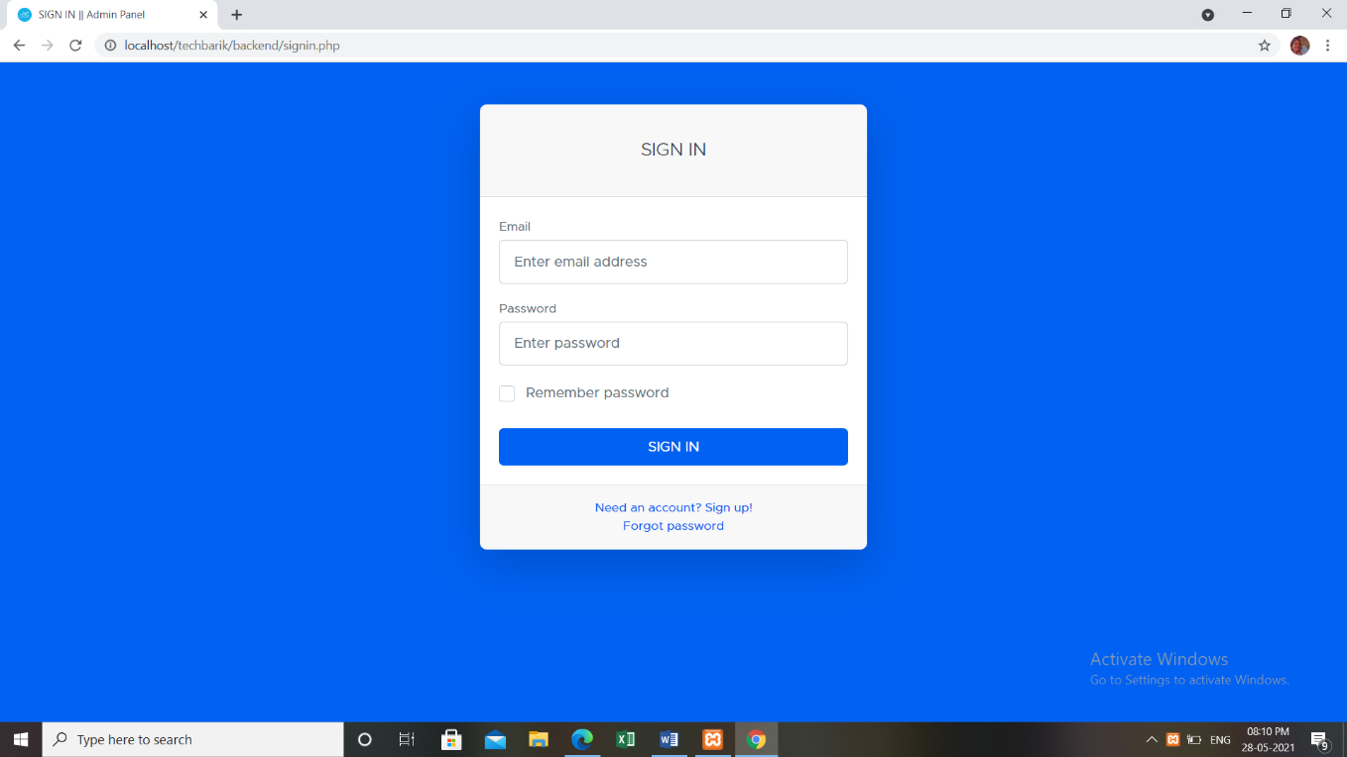

FIG NO.25:Sign in

After signing in,a message is displayed which says that you have signed in successfully.

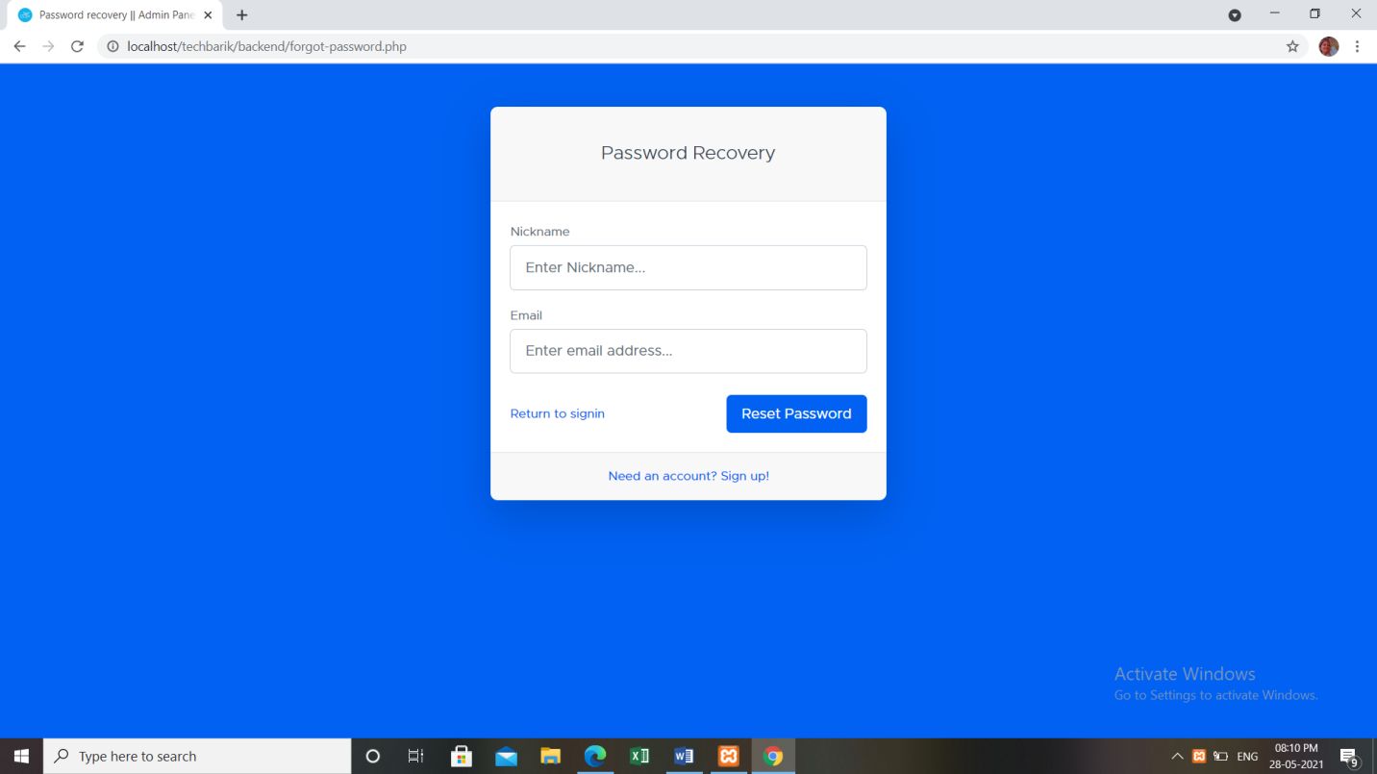

FIG NO.26:Password Recovery

We have Password Recovery option here which is available when someone has created an account.

It takes some of the details and provides the feature to recover our password.

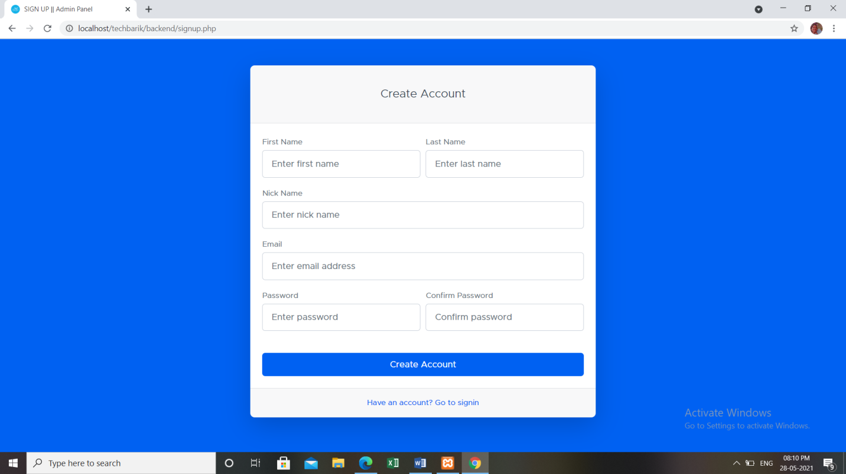

FIG NO.27:Create account

To make an account on the website details like first name,last name,nickname,email address password, and confirm password is asked.After account creation, a message gets displayed which says that our account has successfully created.

As we sign in to the website after accessing localhost/techbarik,this interface is shown and on the left,it shows the username of the person who has signed in to the website.

It is along with the Signout option.

So when someone wants to sign out from the website they can click here.

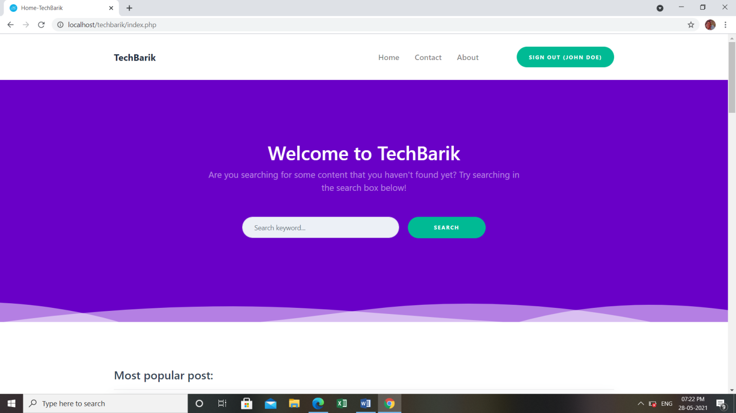

FIG NO.28:User Signed In

There is a message displayed on the interface which says Welcome to Techbarik and then there is a feature when you can search the keyword on what you want to see in this website.

And if the keyword matches with the existing posts then it shows results based on search criteria.

Just beside the Home option,there is a Contact option where the visitor of this website can contact the admin.

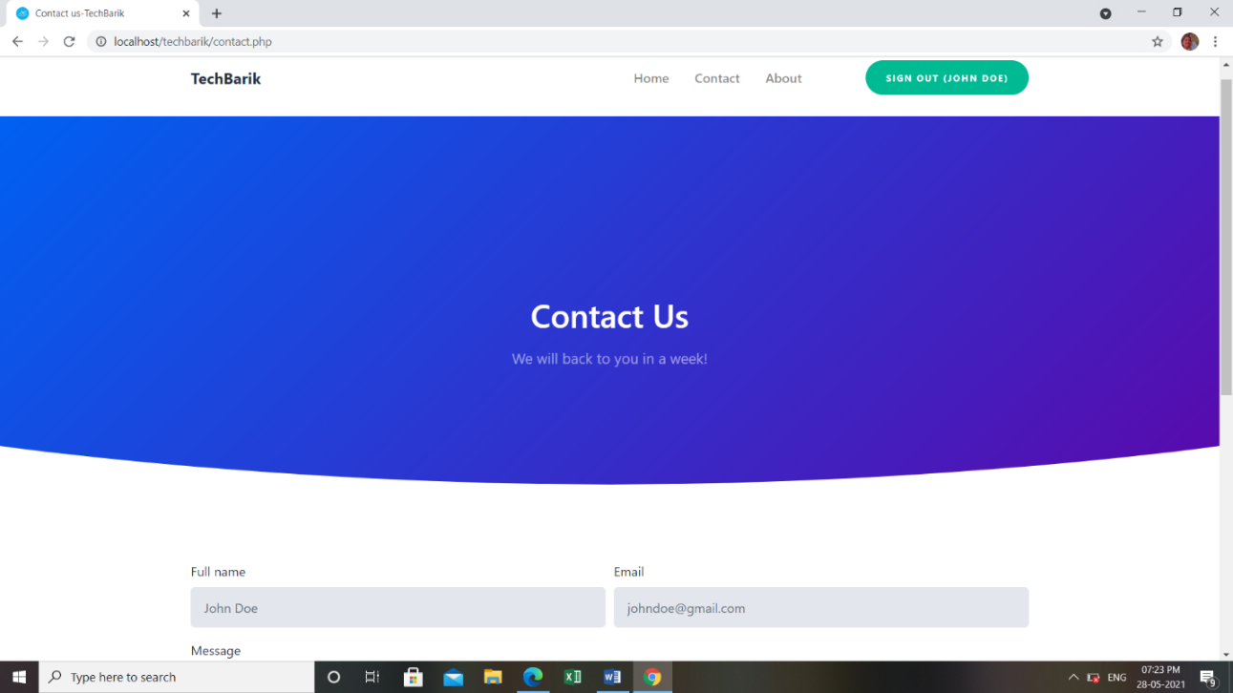

FIG NO.29:Contact Us

The contact page has a message written which says Contact us.To contact the visitor needs to fill in the details like full name,email id, and the message box. Further,if we reply to the message from the backend, it will be shown here as a reply with the dropped message.

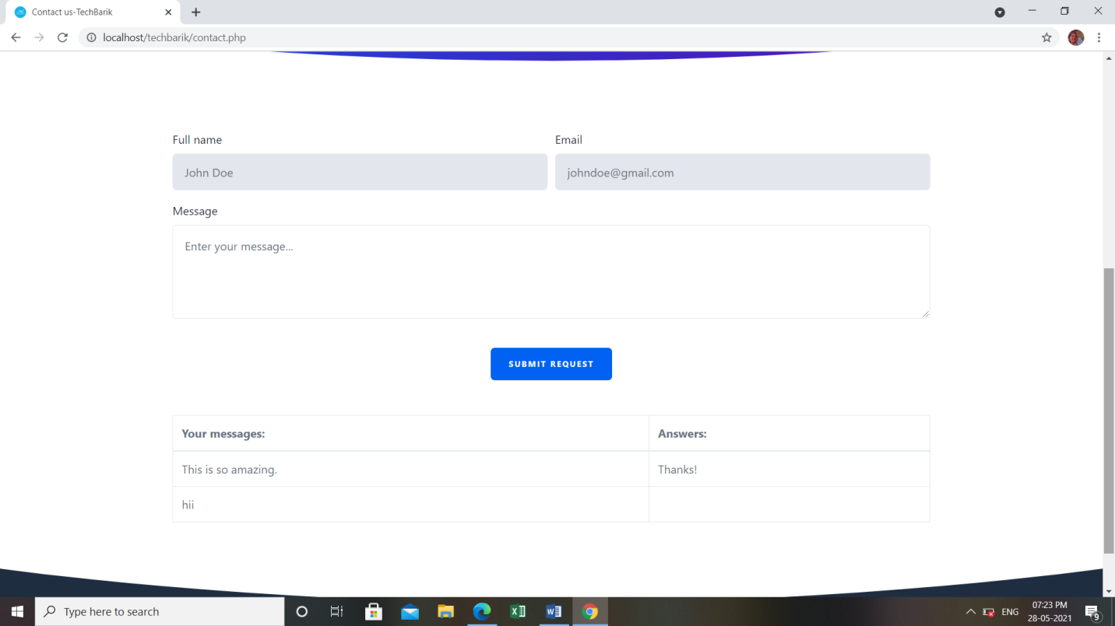

FIG NO.30:Contact Us

Just beside the Contact option,there is the About option which says About us.Here a brief instruction about the website can be written to make it easy understandable by the visitors.

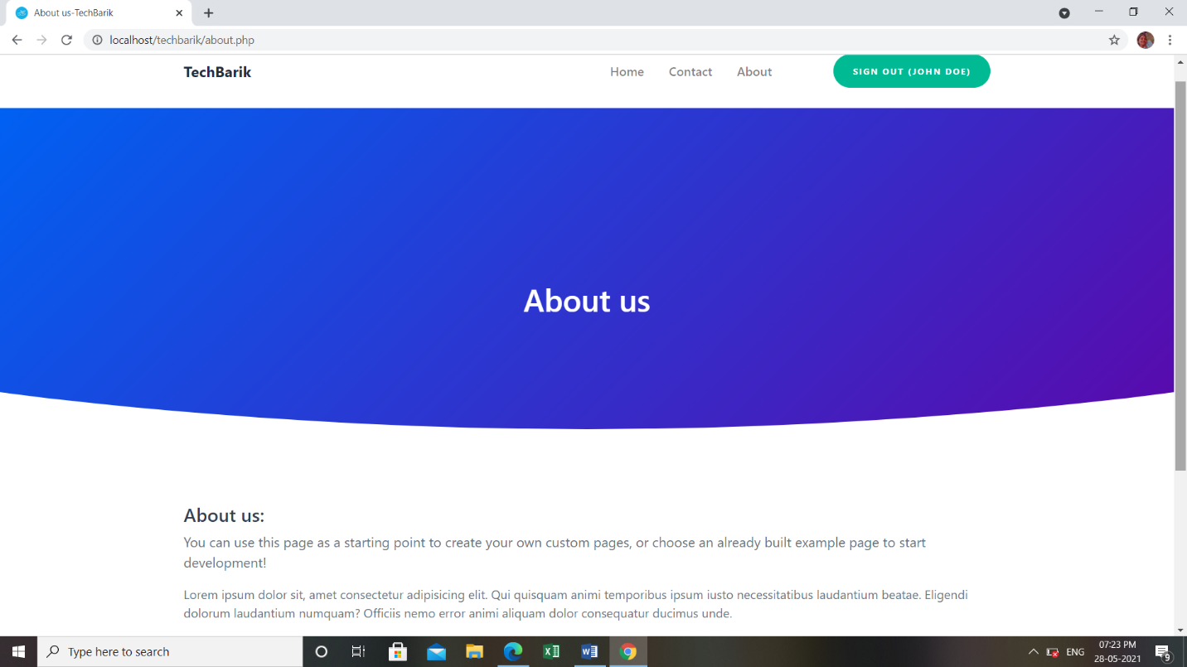

FIG NO.31:About Us

We can write the details of the website and after that on the bottom right there are options like privacy policy and terms and conditions.

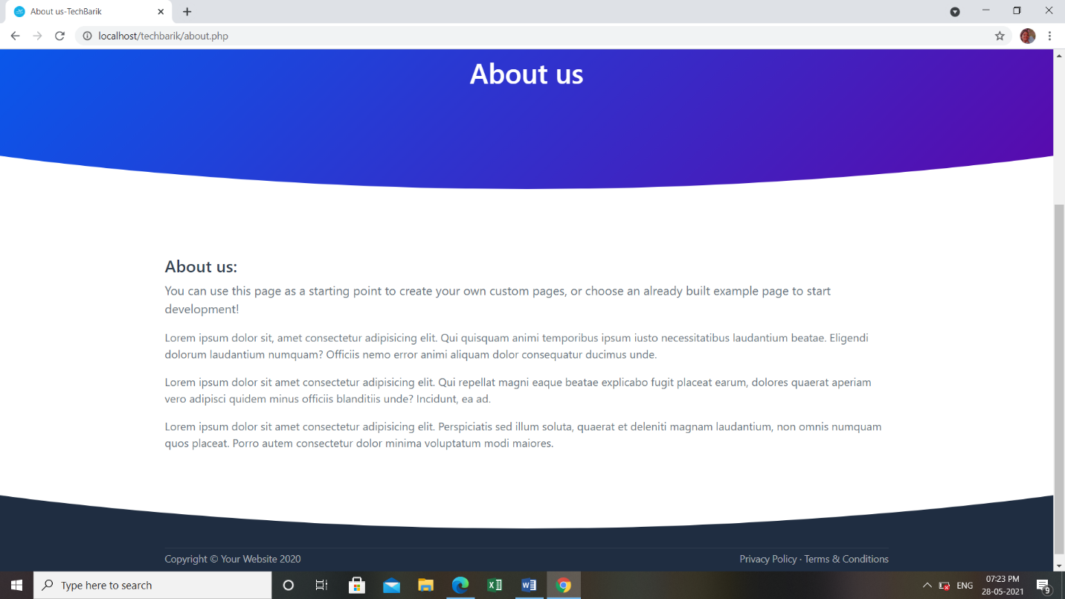

FIG NO.32:About Us

In the privacy policy,the policies of the website can be mentioned in detail so that the user can go through these and know about the policies in detail.



FIG NO.33:Privacy Policy

In terms and conditions,we can specify the terms and conditions regarding the website in detail for visitor’s ease.

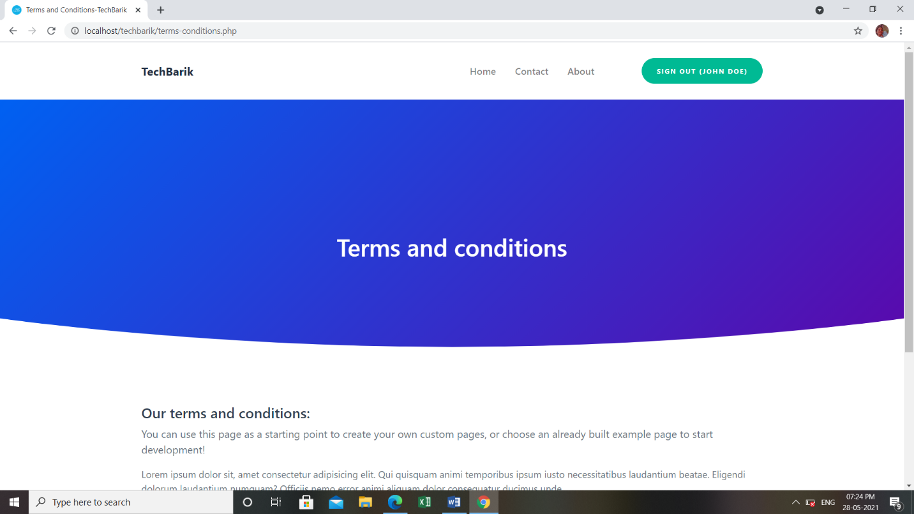

FIG NO.34:Terms and Conditions

In the most popular post section,the post having more number of posts will be displayed and then we can also click on the shown post to go to the post directly.It will also show the name and profile photo with date and time mentioned below.

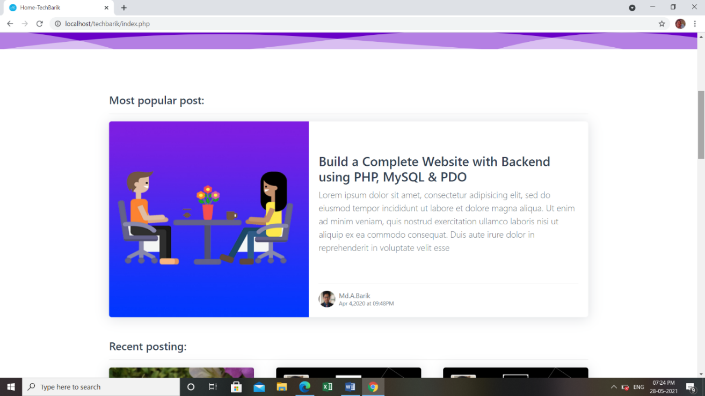

FIG NO.35:Most Popular post

Scrolling down, we have a Recent posting section that shows the posts which have recently been created.Since pagination feature has been applied in pour project,we can shuffle between the posts by just clicking on 1, 2, 3.

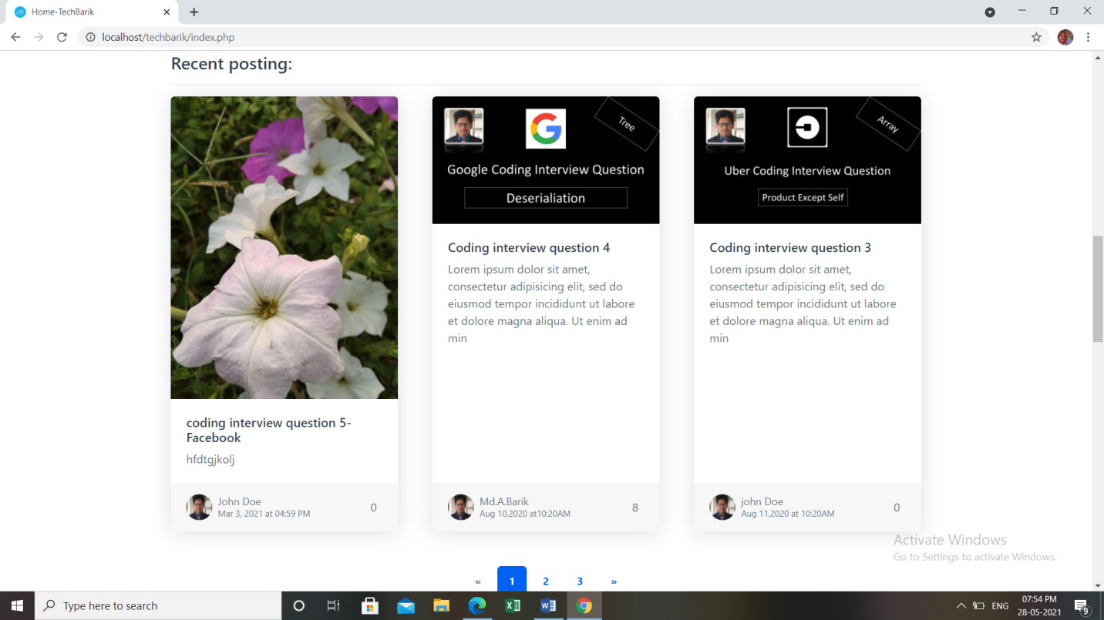

FIG NO.36:Recent posting

The Most viewed section will show the most viewed posts with the user details,time and date, and the views of a particular post at the bottom right side of the post.

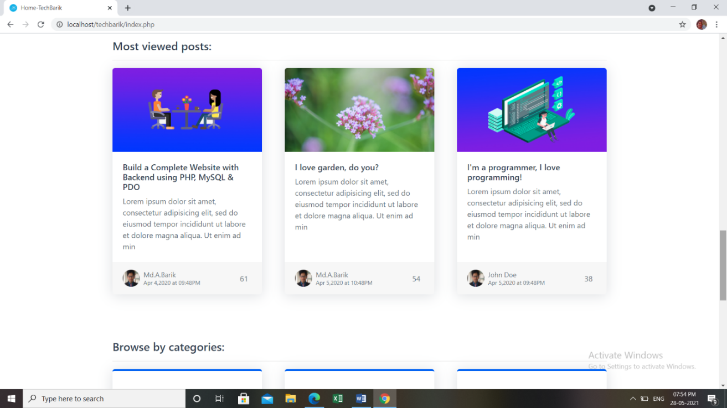

FIG NO.37:Most viewed posts

As we scroll down we have Browse by categories option, where there are four categories having some posts in each of the categories.The categories names are Programming,Lifestyle,PHP, and CTCI.

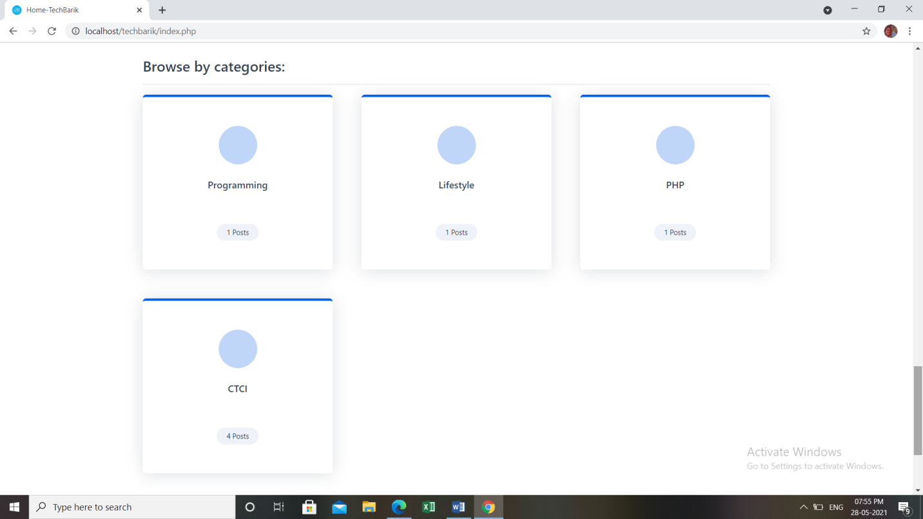

FIG NO.38:Browse by categories

The category of programming has an interface like this which shows a message Welcome to programming category and then there is a search option too where we can search.Since the programming has only one post,so it will show that very post with the views in the most popular post,recent post, and most viewed post when we scroll.

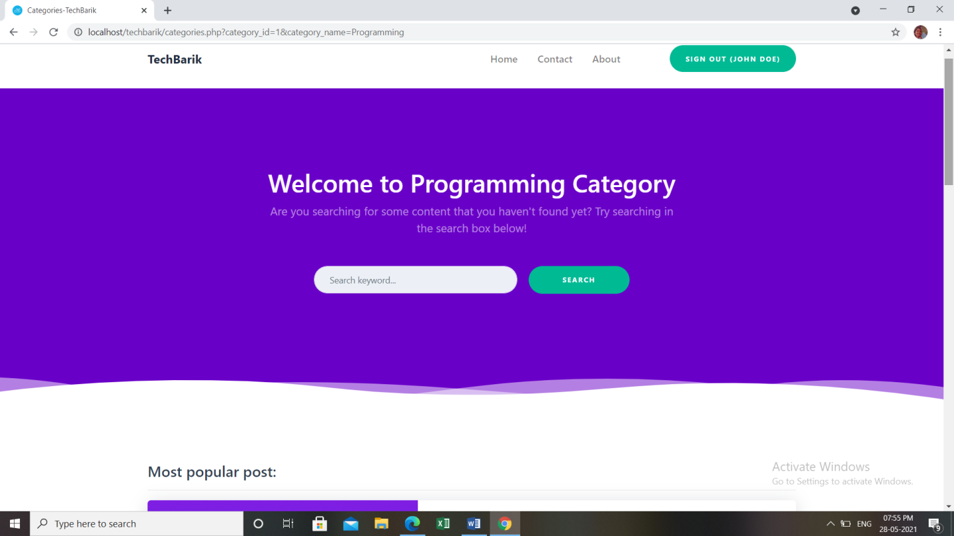

FIG NO.39:Programming Category

Similarly,we have only one post in the Lifestyle category so it will show the same post in most popular post section,recent posting and most viewed post when we scroll down.

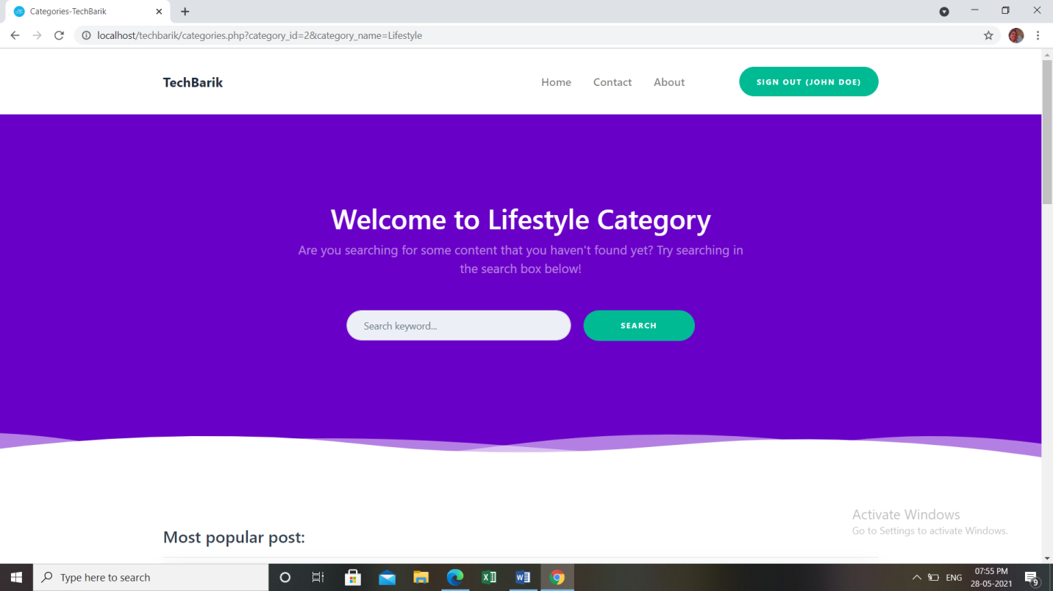

FIG NO.40:Lifestyle Category

Likewise,Programming and Lifestyle category,PHP category has only one post.So it will also show one post in the most popular post,recent posting and most viewed post when we scroll down.

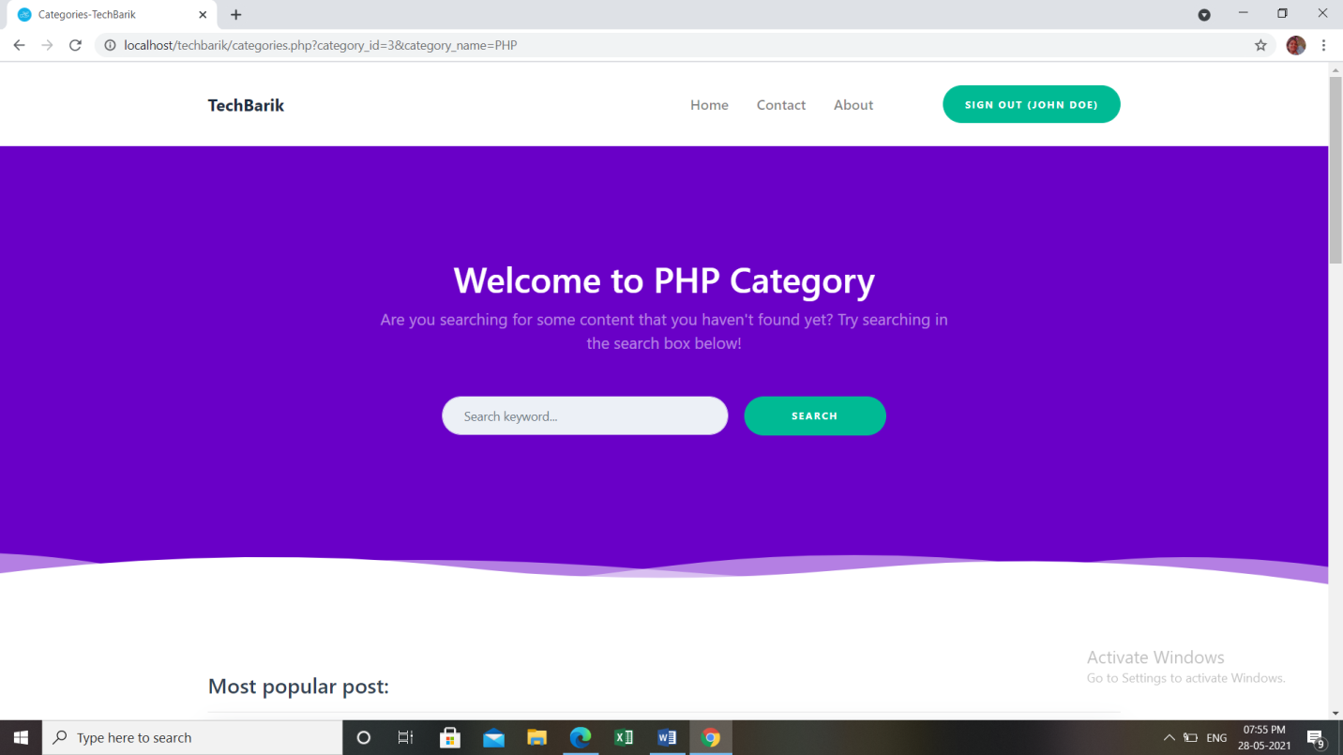

FIG NO.41:PHP Category

In CTCI Category we have four posts.The post having more number of views will be shown in the most popular post section.Then in Recent posting section, the recent post created under the CTCI category will be shown with views Since we have more than one post in this category,we can shuffle between the posts by clicking on 1 or 2.

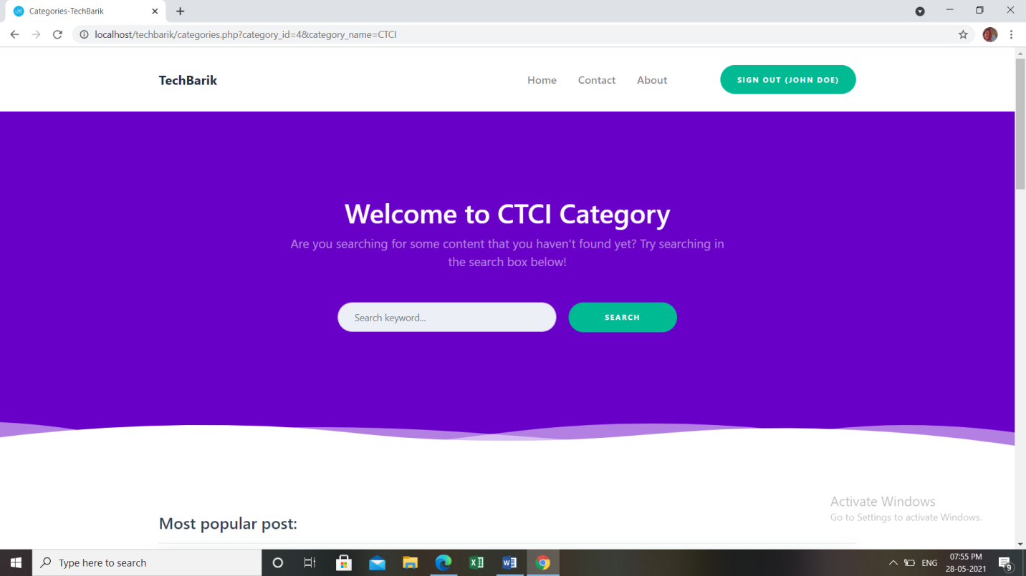

FIG NO.42:CTCI Category

**Backend of our Website**

In the Backend of Website,Dashboard contains all the information including all posts,comments,categories and users.From backend admin can delete and update the informations present on the website.

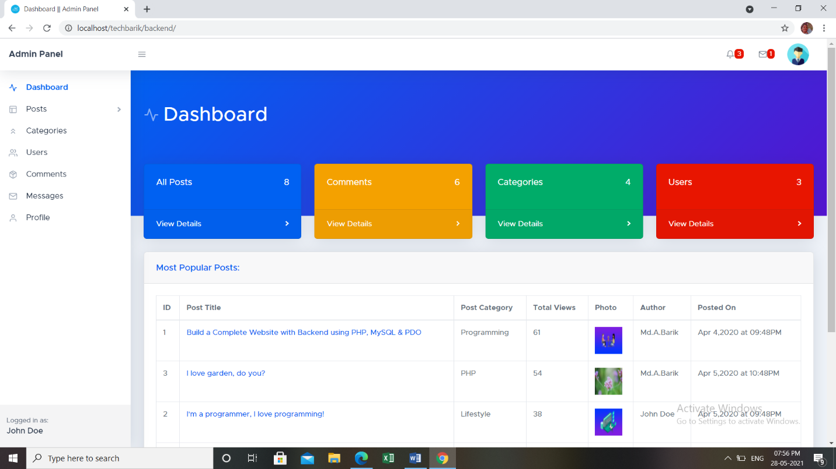

FIG NO.43:Dashboard

The user who has been given the permission of admin from database can access the backend of the website and to access it the user should be logged to the website. In the dashboard,all the details are there including Posts,Categories,Users,Comments,Messages, and Profiles.

The admin can access backend by typing localhost/filename/backend.After accessing it,admin can modify posts or category and can also send response to the messages of visitor.

Under the Post option,there are two sub-options.

The first one is All Posts and the second one is Create New Post. In the All posts section all the posts regardless of any category are shown with the post details.The post details are Title,status,CategoryAuthor,Image,Date,Details,Tags, Comments,Views,Edit and delete.

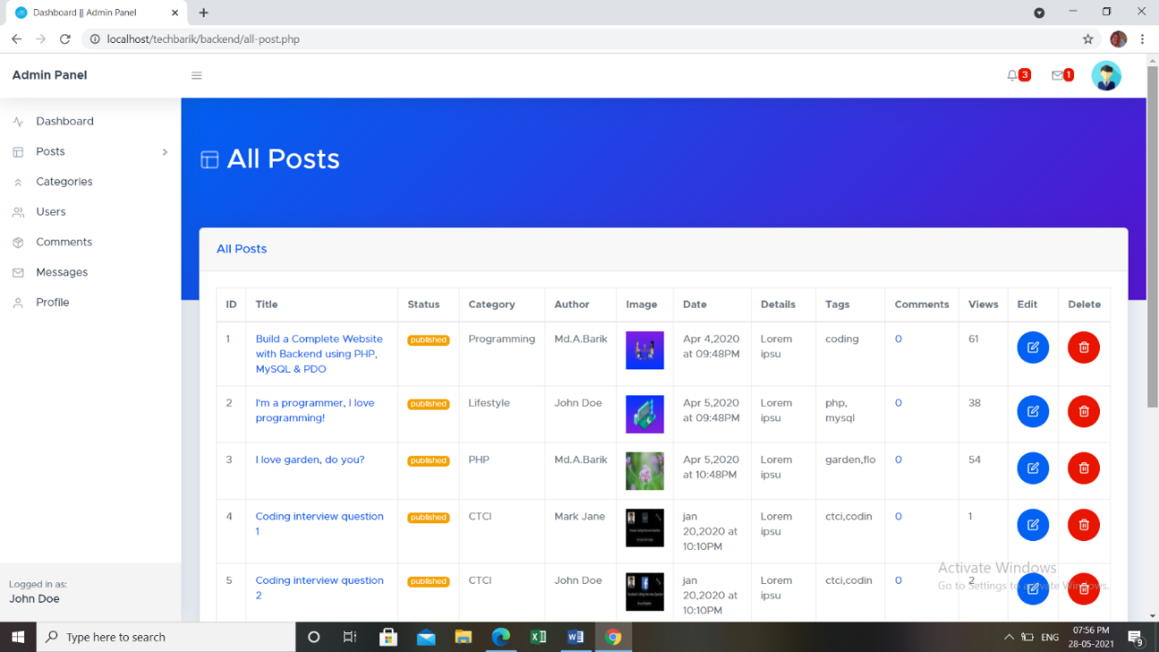

FIG NO.44:All Posts

Then inside the create new post,we can create a new post of any particular category from backend. And for that we need to fill in the details like Post title,post status,select category,choose photo and post details.

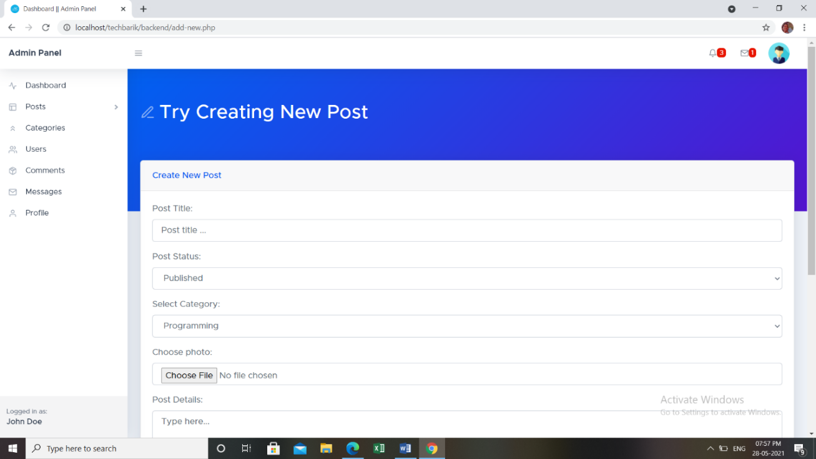

FIG NO.45:Creating New Post

In the category section,all the categories that we have created on the database are shown with the details like total posts inside that category,created by,status edit and delete.

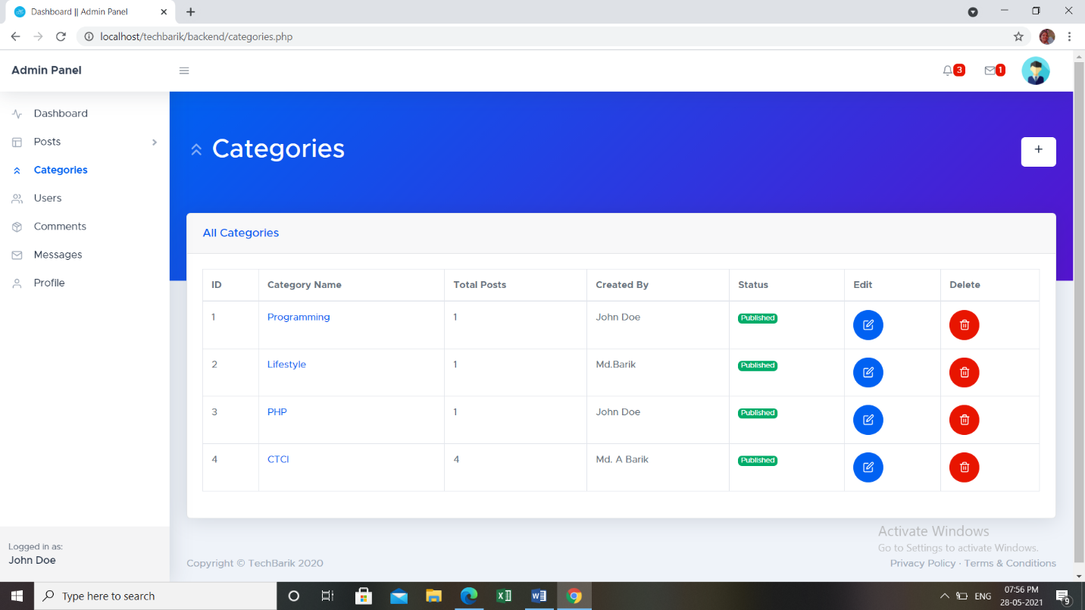

FIG NO.46:Categories

To create a new category we need to click on the plus icon on the right side.As soon as we click on that Create new category tab will appear which will ask for the details to be filled.

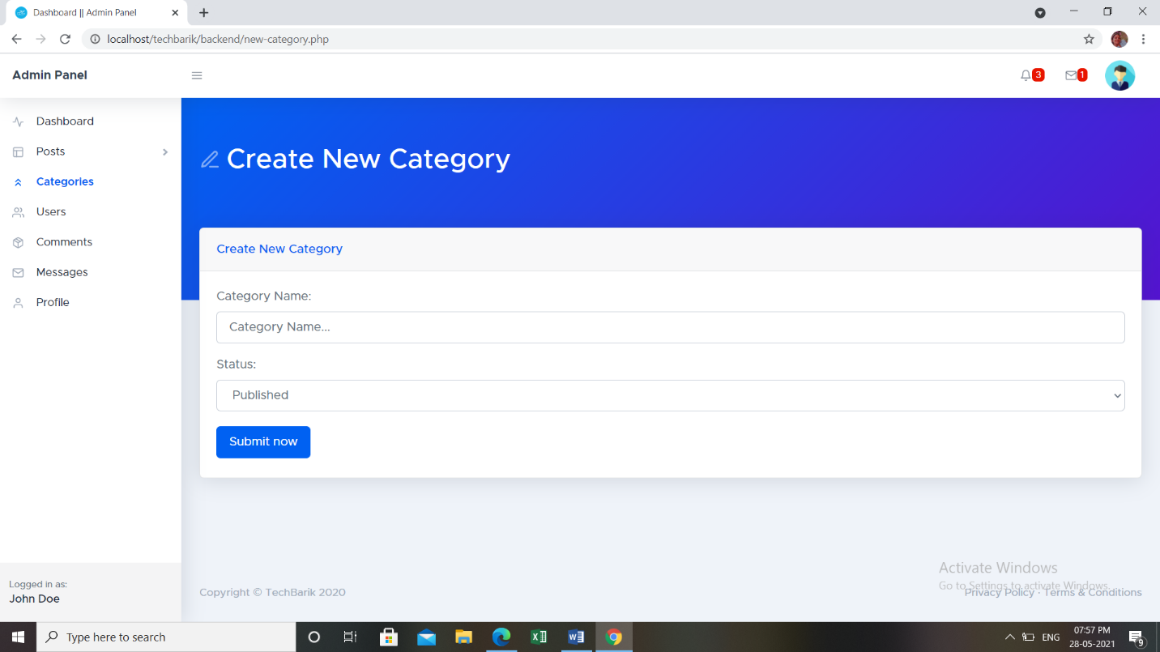

FIG NO.47:Create new Category

The users' section will have all the users who have signed in to the website with the details like user email,photo,registeration date,user role,edit and delete.

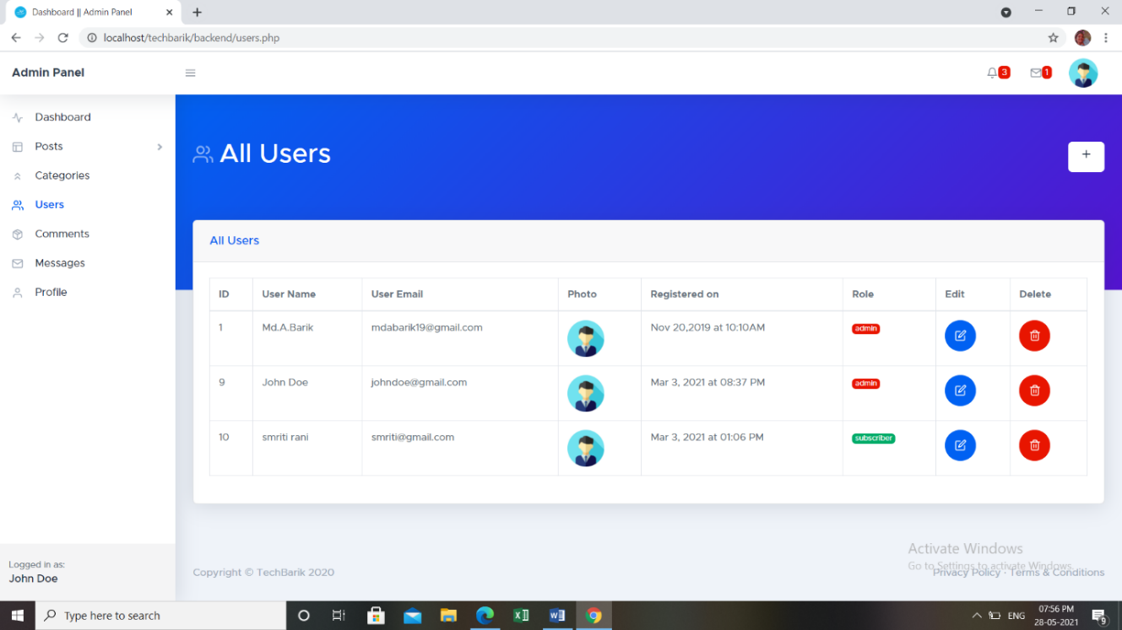

FIG NO.48:All Users

To create any new user we need to click on the plus icon,then we will be asked to fill the details like user name,nick name,user email,user password,user role etc.

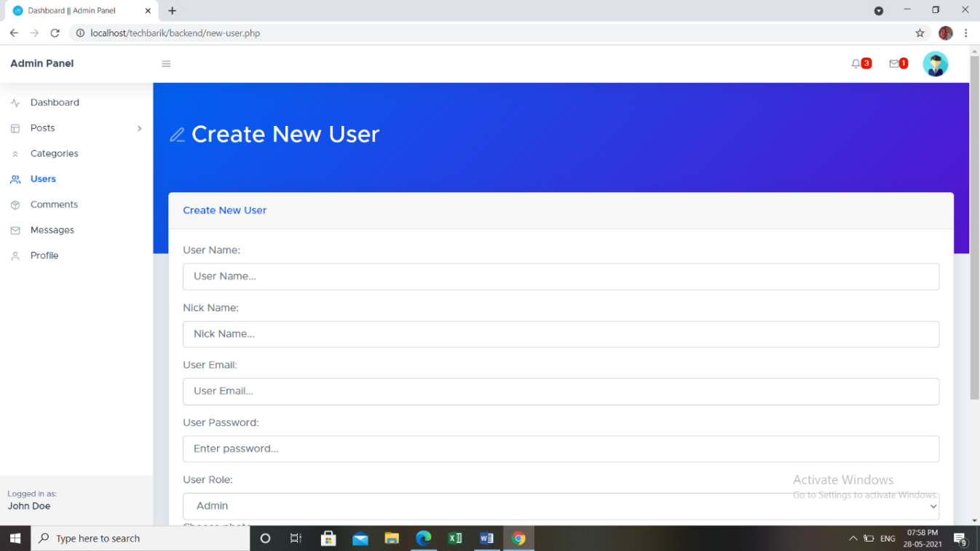

FIG NO.49:Create New User

Inside comment,all the comments will be displayed which we have till now with the user email, user name,comment,date,status,approve,disapprove and delete.

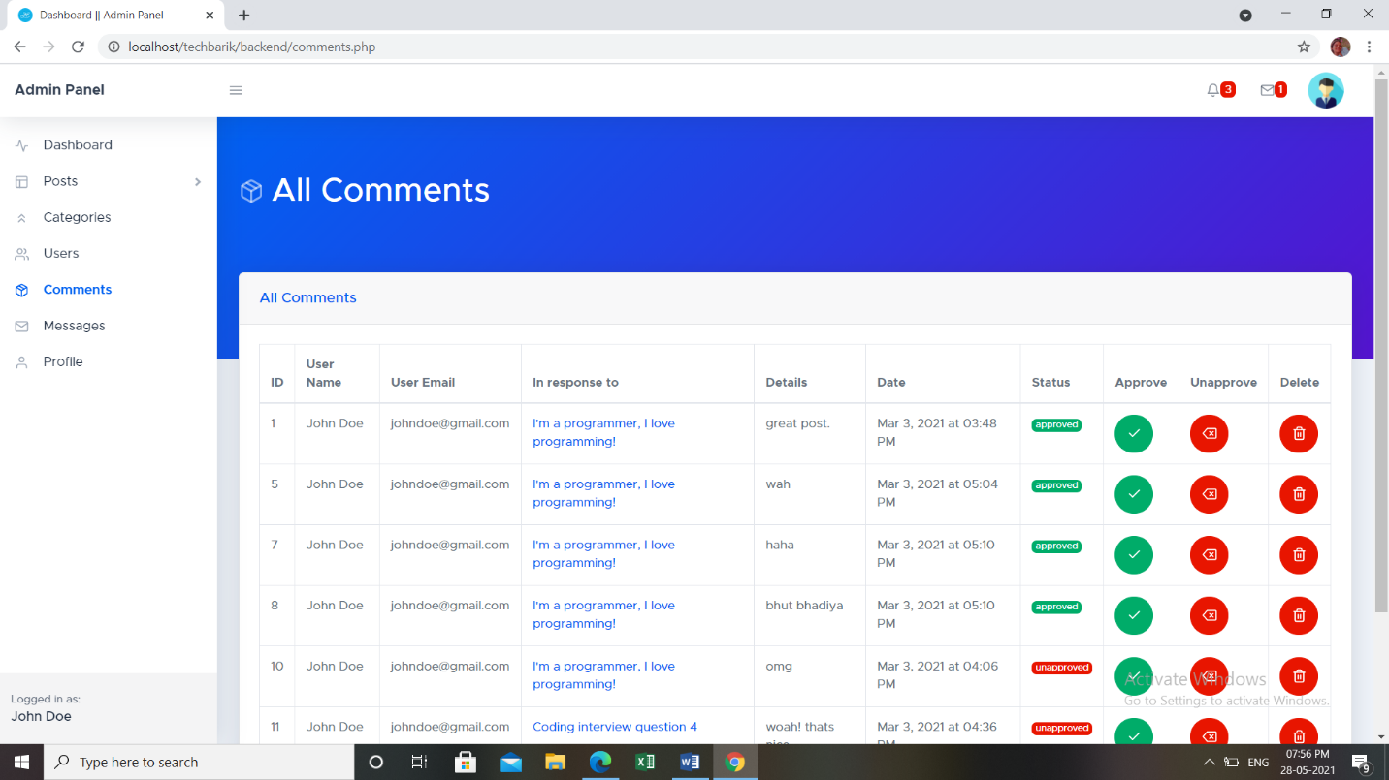

FIG NO.50:All Comments

The message section will show the message of the visitor who contacted the admin of the website. It has columns like user name,user email,message,date,status,response and delete.

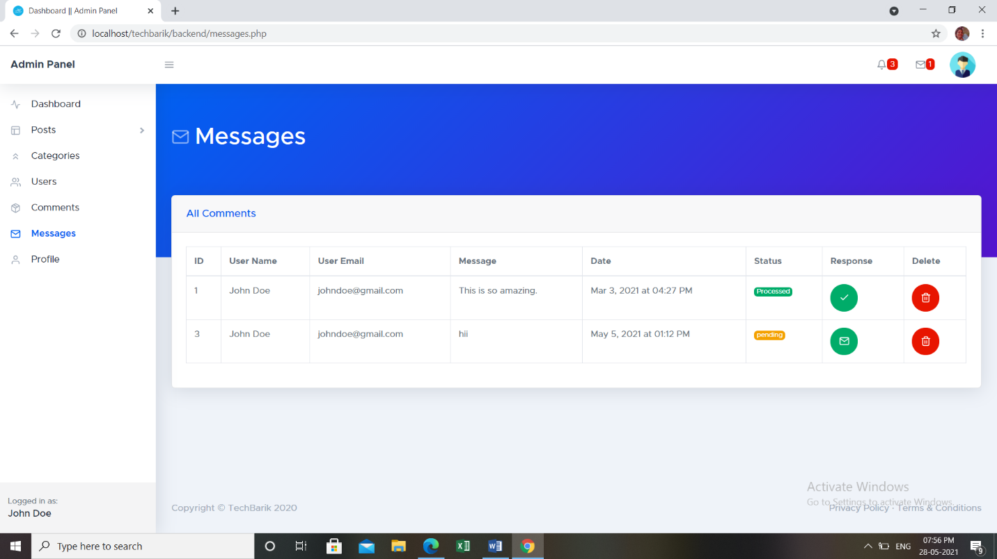

FIG NO.51:Messages

At the top, there are two options. The first one is of Notifications and other one is Message notification.In the notifications there are the comments which have not been replied.The comments can be on any post of any category.

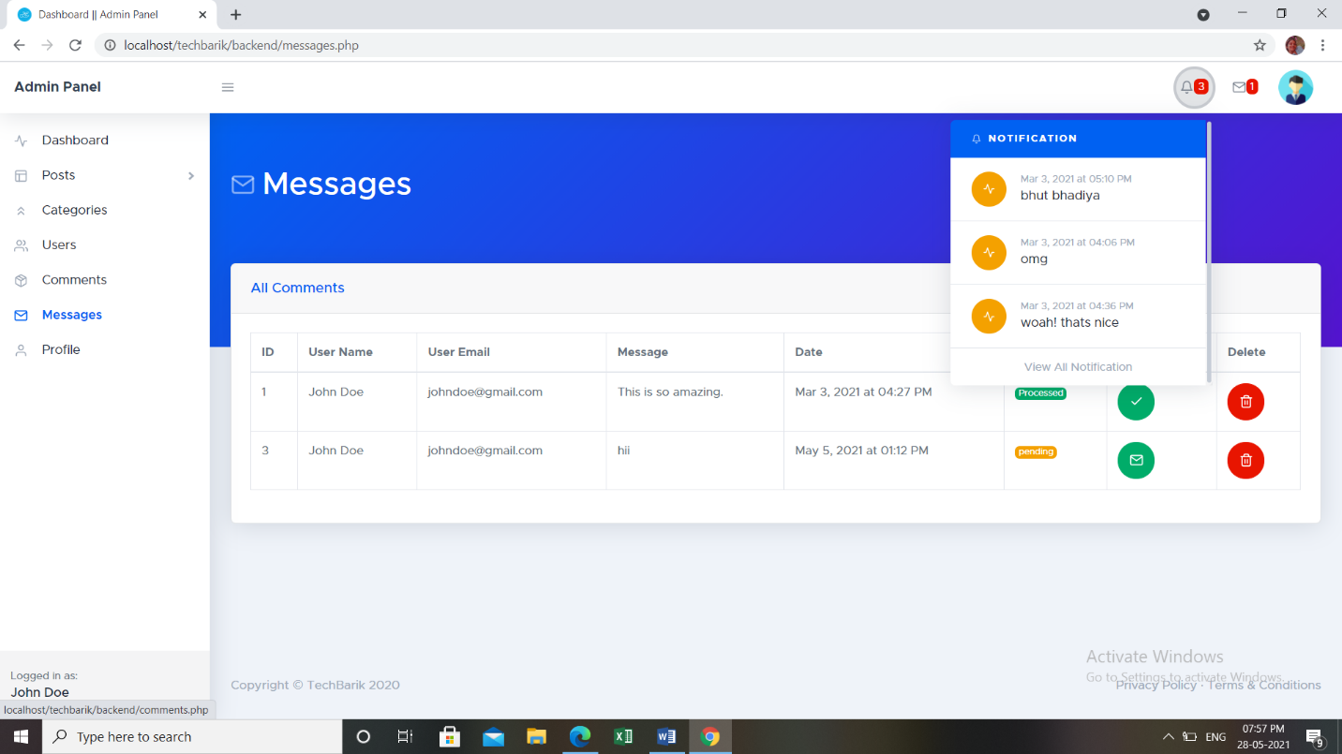

FIG NO.52:Notifications

In the message notification, the visitor’s messages are shown.As soon as the admin replies to any message that message gets disappeared from the message notifications section.

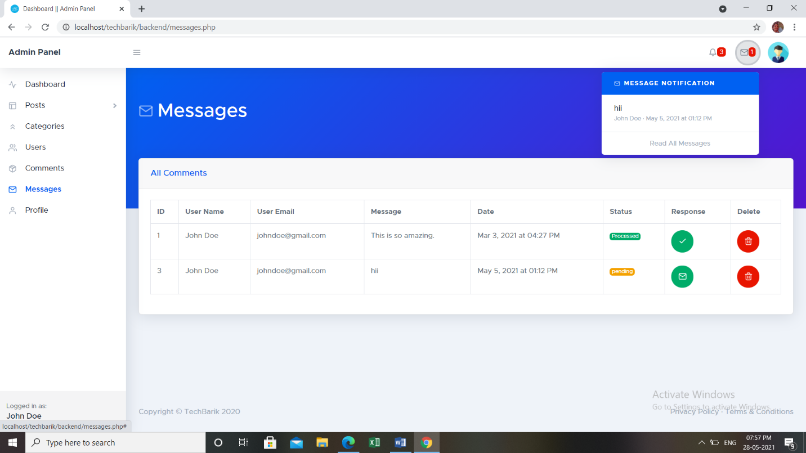

FIG NO.53:Message Notifications

Under the profile section,Profile photo, Username and the email id of the admin are displayed.

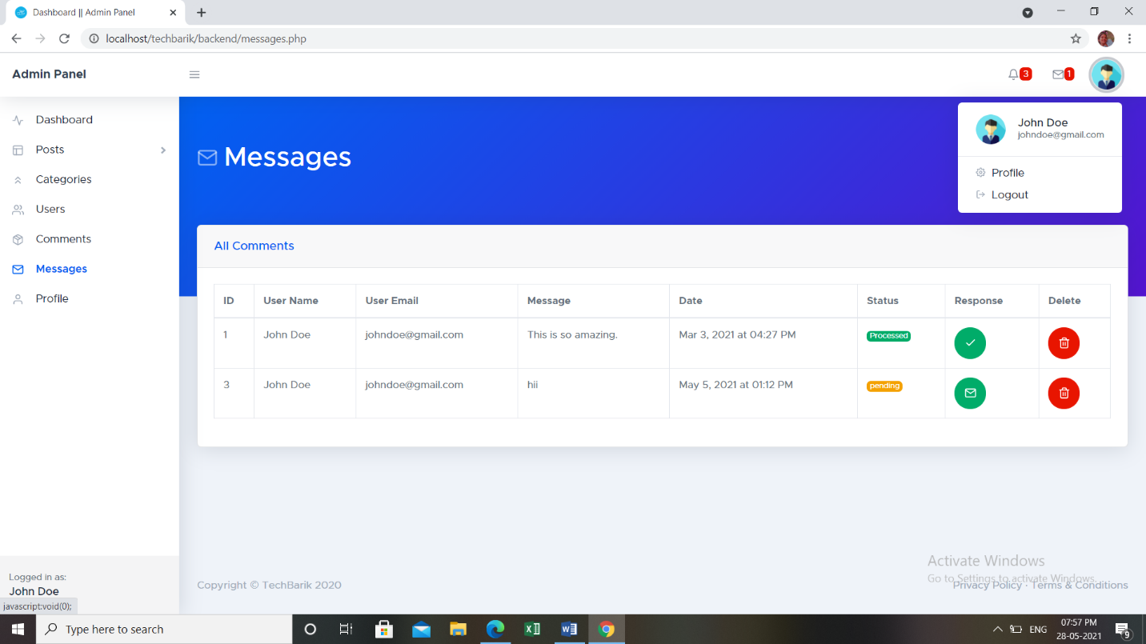

FIG NO.54:Profile

Inside the profile section,admin can edit the details of themselves which can be updating the name, email id and profile photo.

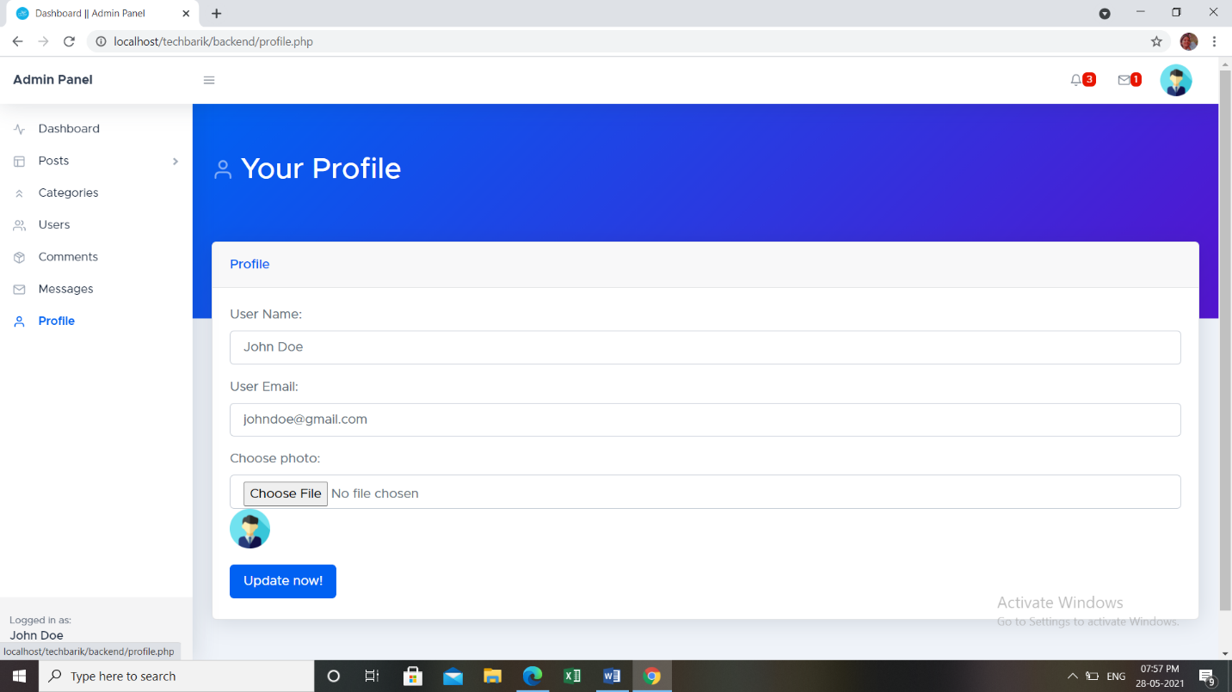

FIG NO.55:Profile

**CODE INPUT**

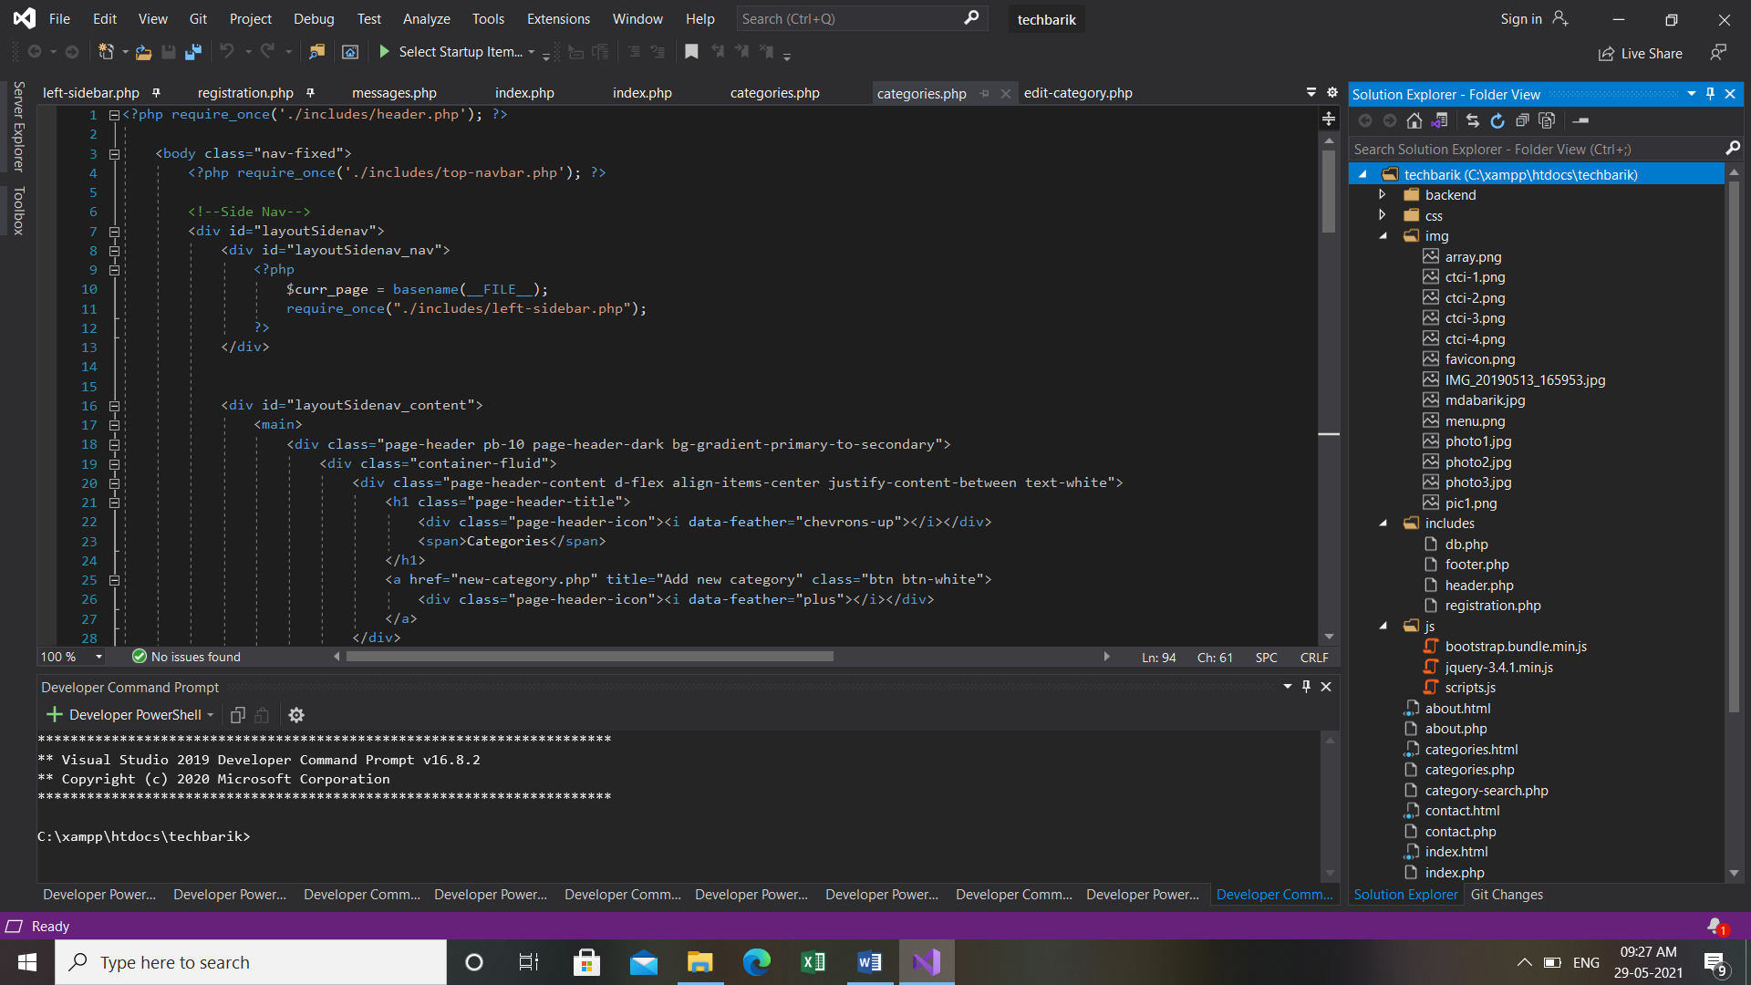 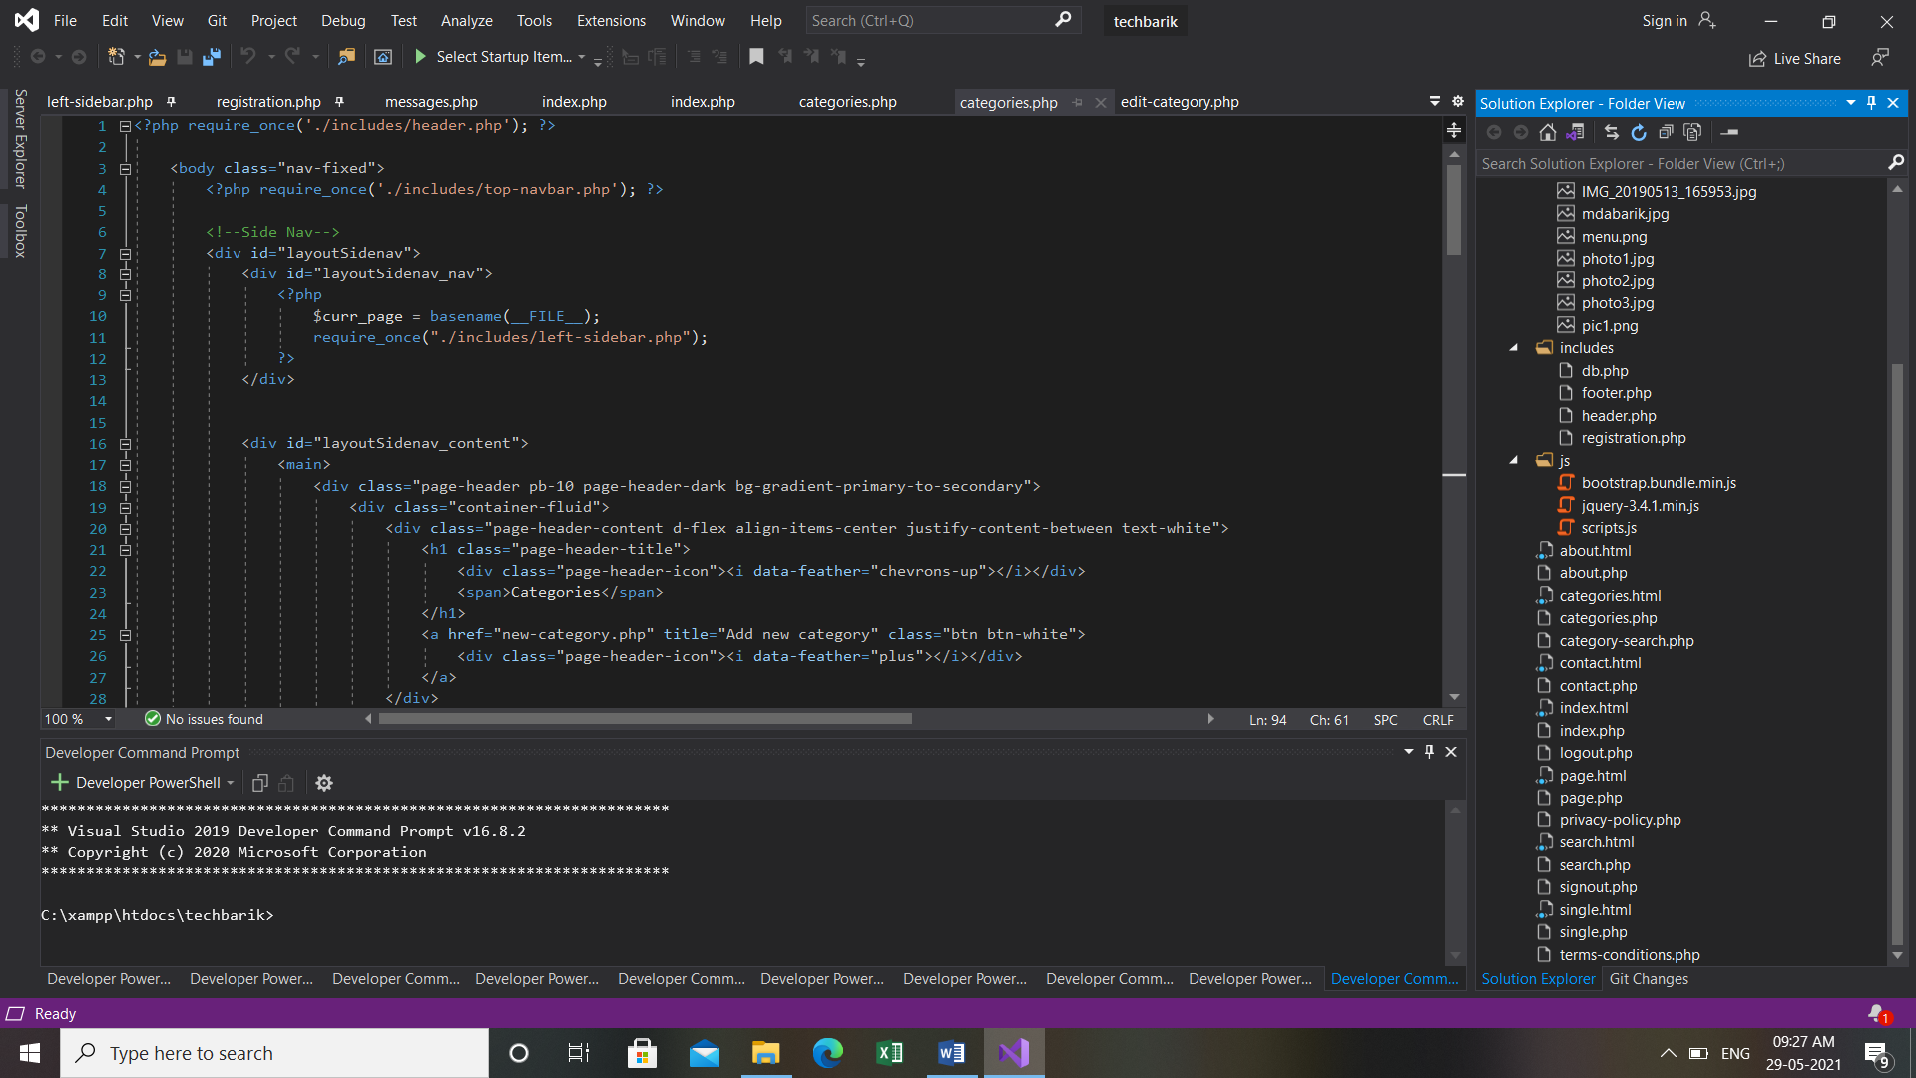

FIG NO.56:Code Input FIG NO.57:Code Input

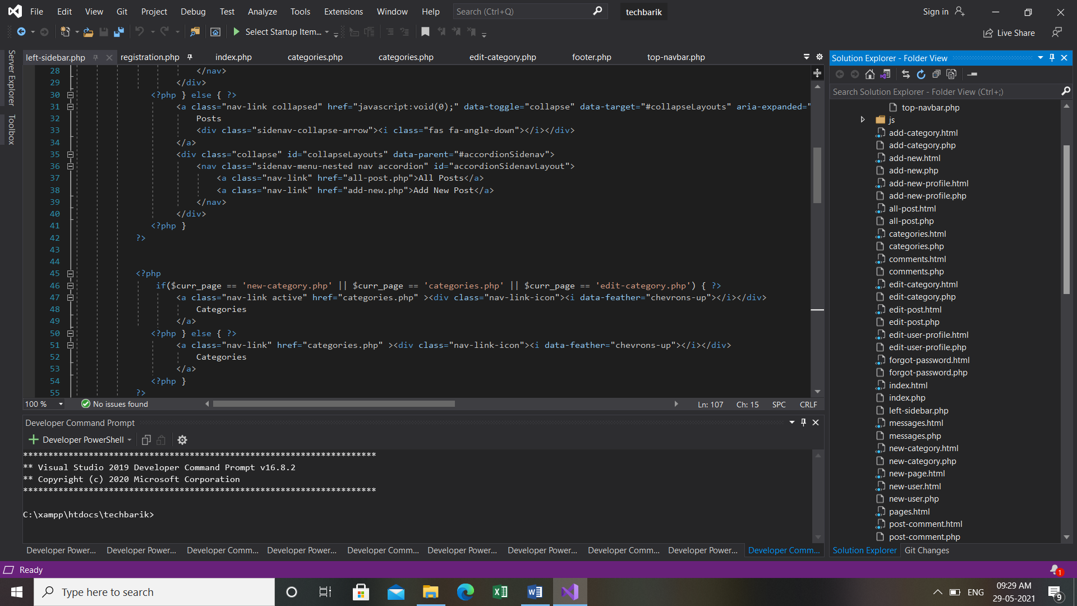 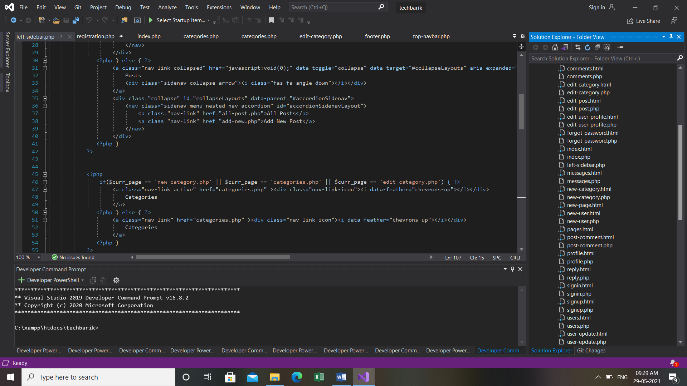

FIG NO.58:Code Input FIG NO.59:Code Input

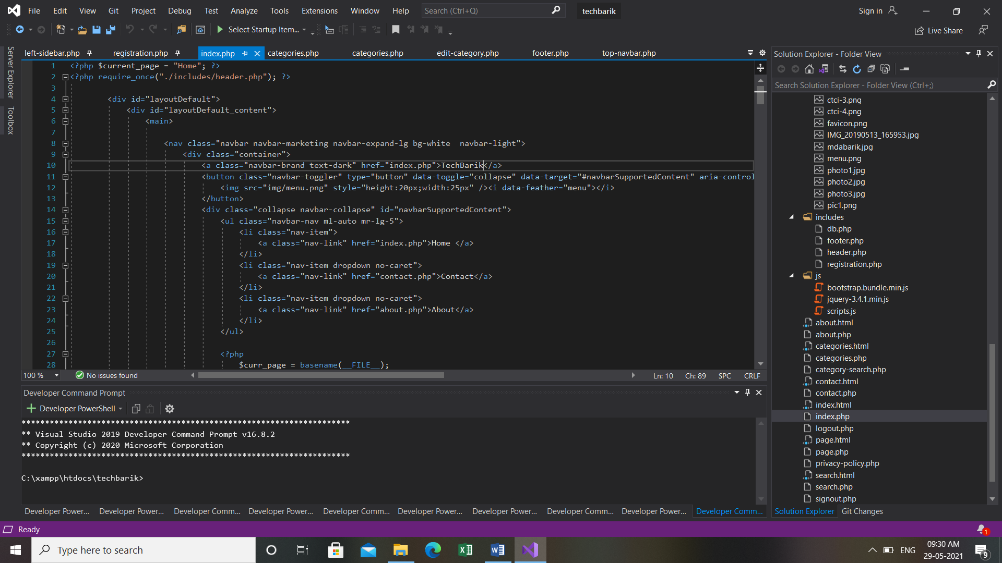

FIG NO.60:Code Input

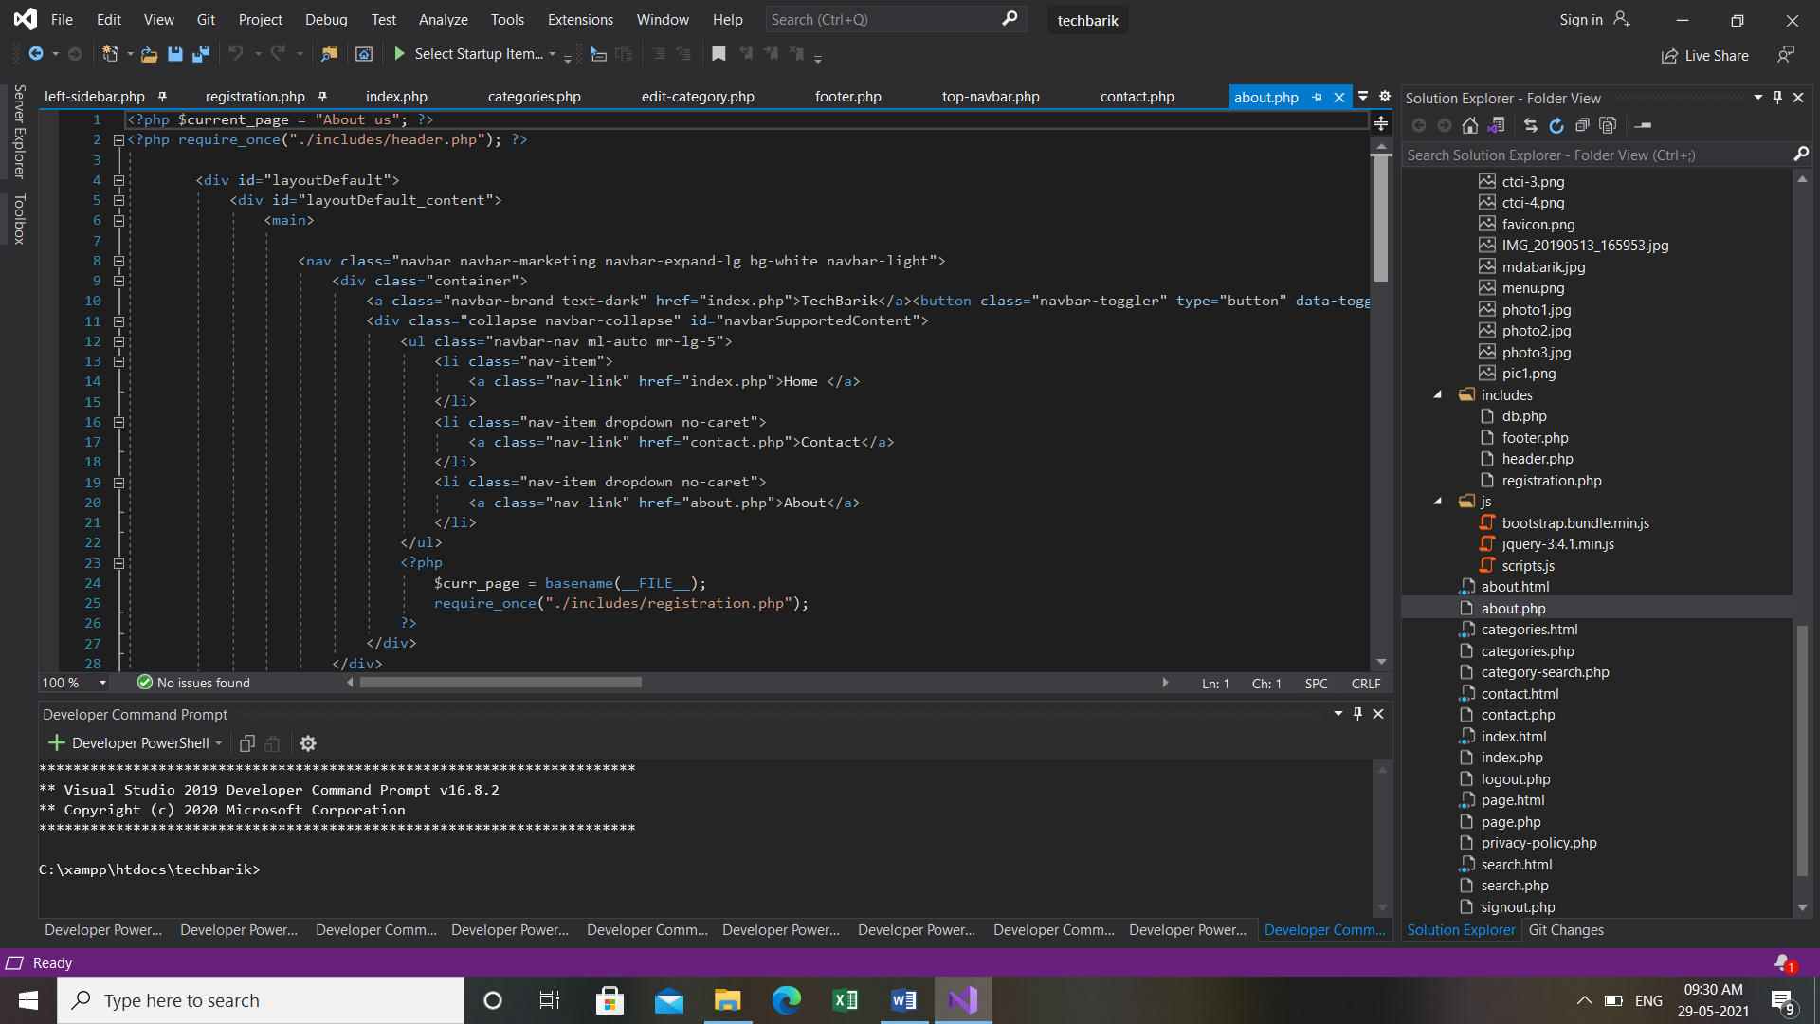

FIG NO.61:Code Input

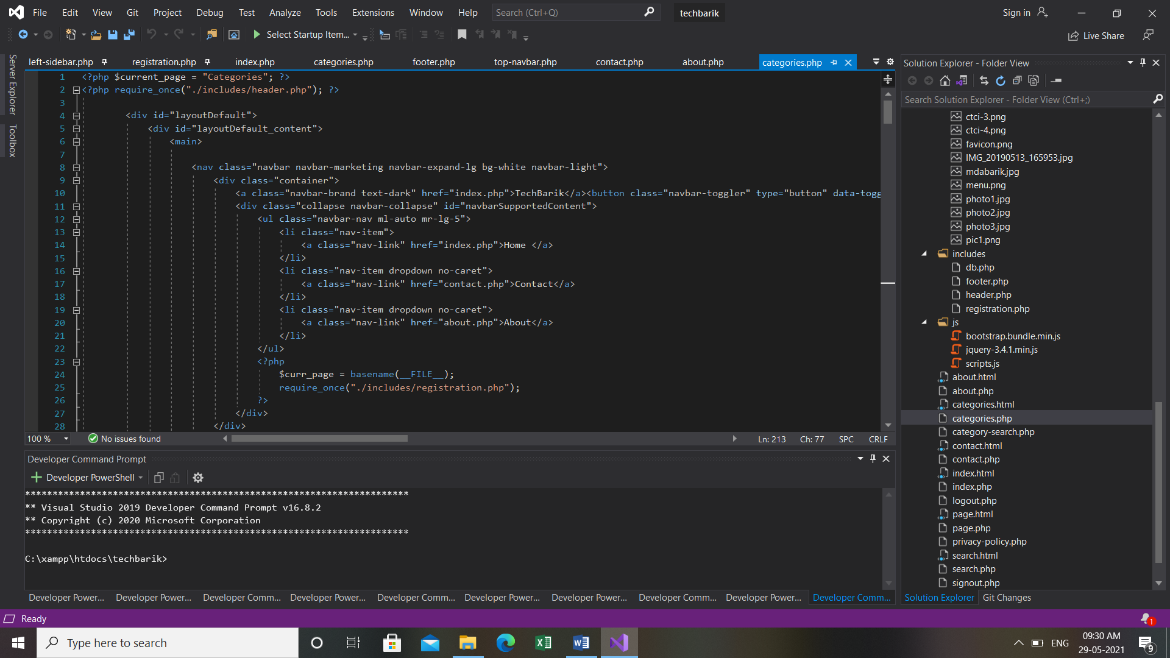

FIG NO.62:Code Input

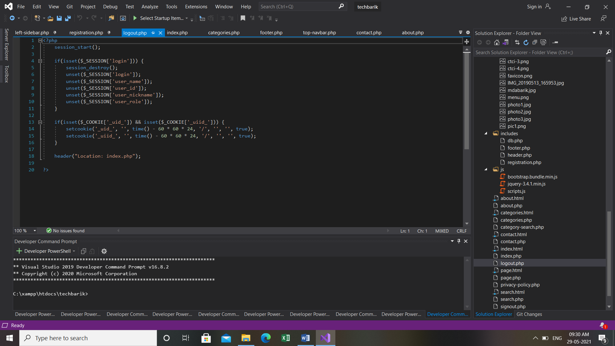

FIG NO.63:Code Input

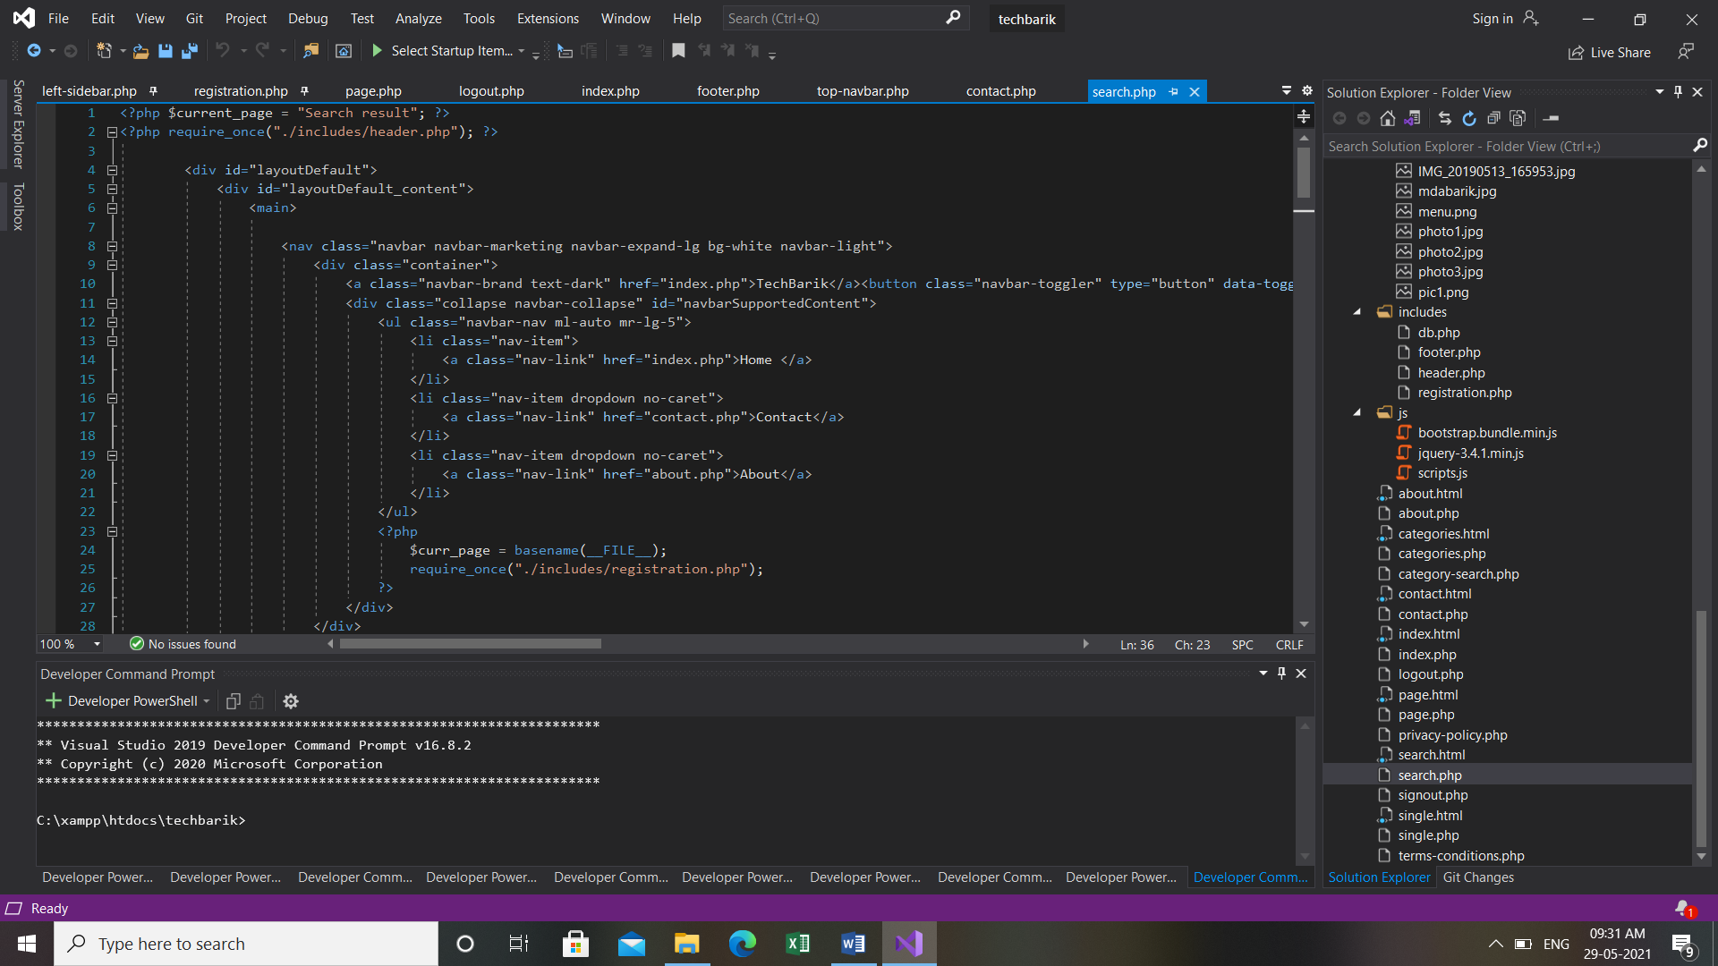

FIG NO.64:Code Input

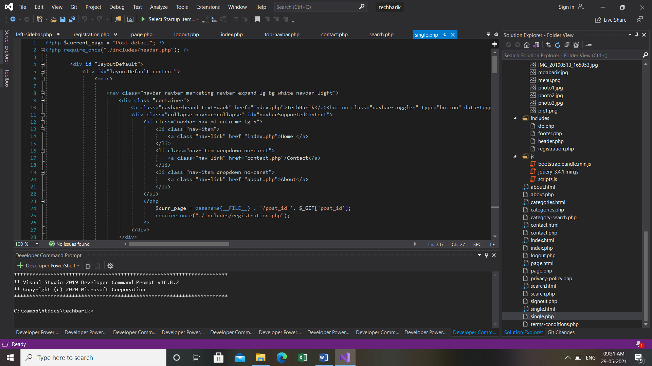

FIG NO.65:Code Input

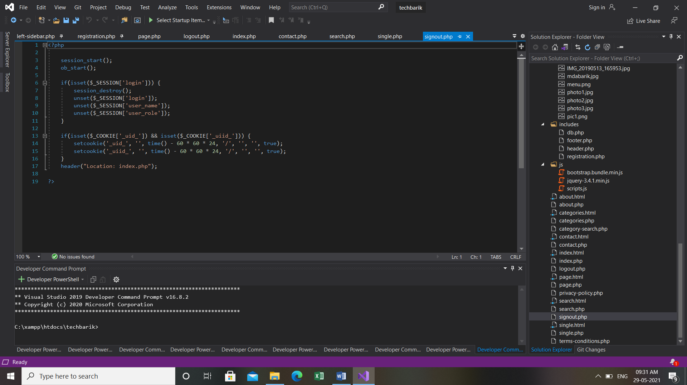

FIG NO.66:Code Input

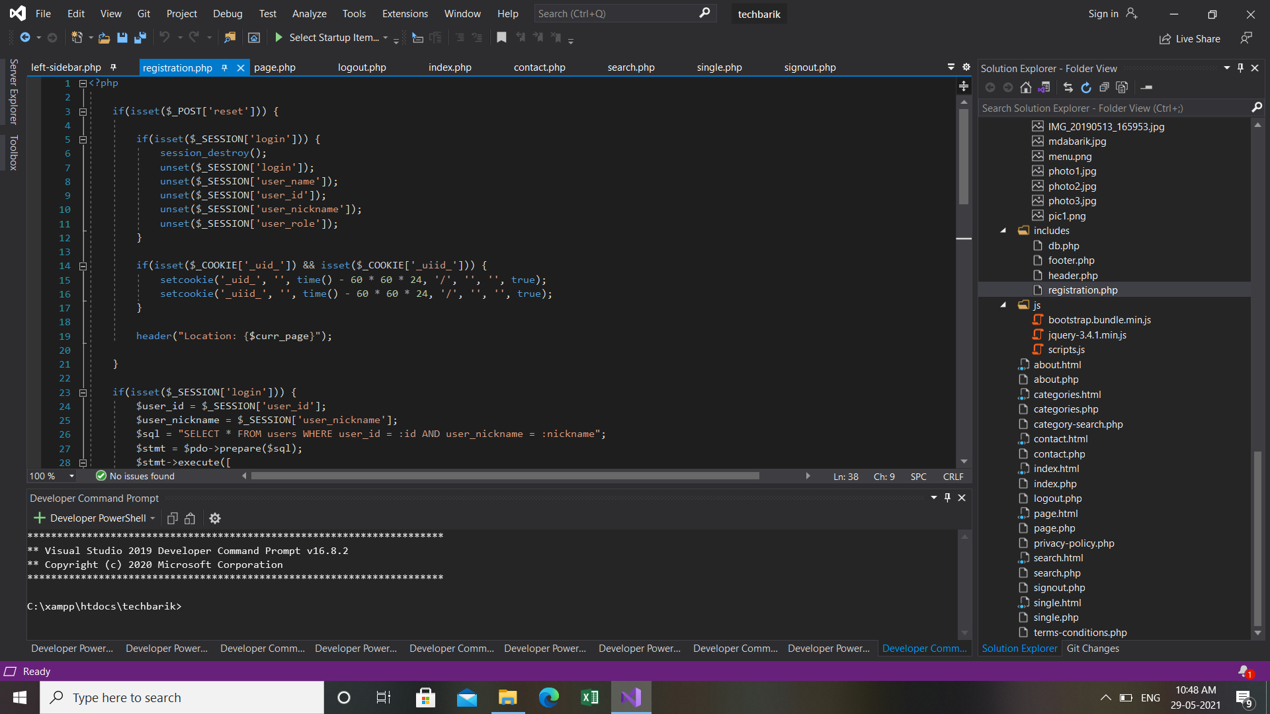

FIG NO.67:Code Input